Sims Parent Lite
Keeping your information up to date:
As an Academy we want to ensure we have the most up to date information on you and your child/children. Sims Parent Lite will provide parents with an effective, convenient and user friendly platform to access, review and request changes to the data the Academy holds. These changes can be made directly from your smartphone, tablet or PC on IOS, Android or via your browser. You will be able to provide additional information on crucial details such as medical information or dietary needs. When a change request is submitted by you, an alert is sent to the school office. Staff will review requests and update our student database, eliminating manual errors. Notifications will be sent to remind you to update your child’s consents or parental consents throughout the year. Please note Sims Parent Lite will replace the annual TS0E3 paper form. The paper form will still be available from reception if needed.
With the General Data Protection Regulation (GDPR) having been introduced in May 2018 schools have new requirements around the way they use student and parent data. SIMS Parent Lite helps schools comply with the new GDPR data requirements, by providing a simple way to collect, manage and handle information by obtaining accurate data securely from parents.
Getting Started:
We will send an activation email to your home email address. Simply click on the link from your tablet, pc or smartphone to activate your account. You can then login using your normal Facebook, Twitter, Google or Microsoft username and password. You will be able to see all children for whom you have parental responsibility on the app once registered, or you can easily create an account on any of the platforms.
The email will be from noreply@sims.co.uk in your Inbox. If not there, check in your Junk mail.
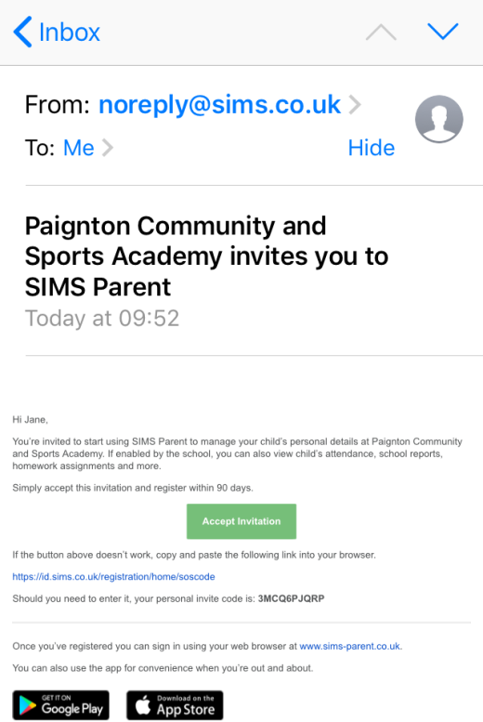

Click the ‘Accept Invitation’ button within the email

Log in with your preferred account

DO NOT USE

Please DO NOT try and register with Sims ID as this is an internal registration system and will not work for parents.
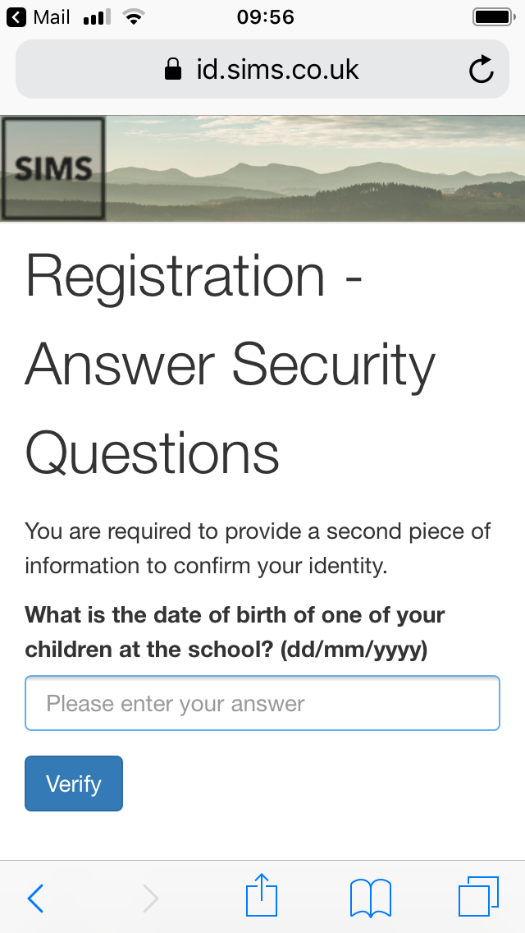
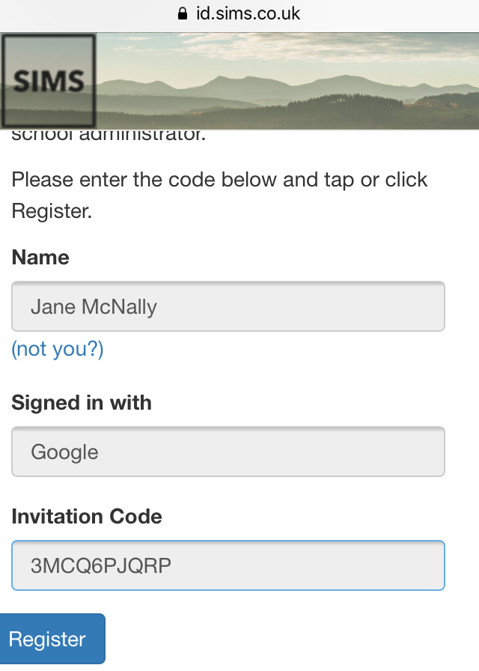

Enter the date of birth of one of your children at the academy using dd/mm/yyyy format
The invitation code field may be populated automatically. If not, copy and paste in the code from the email invitation.

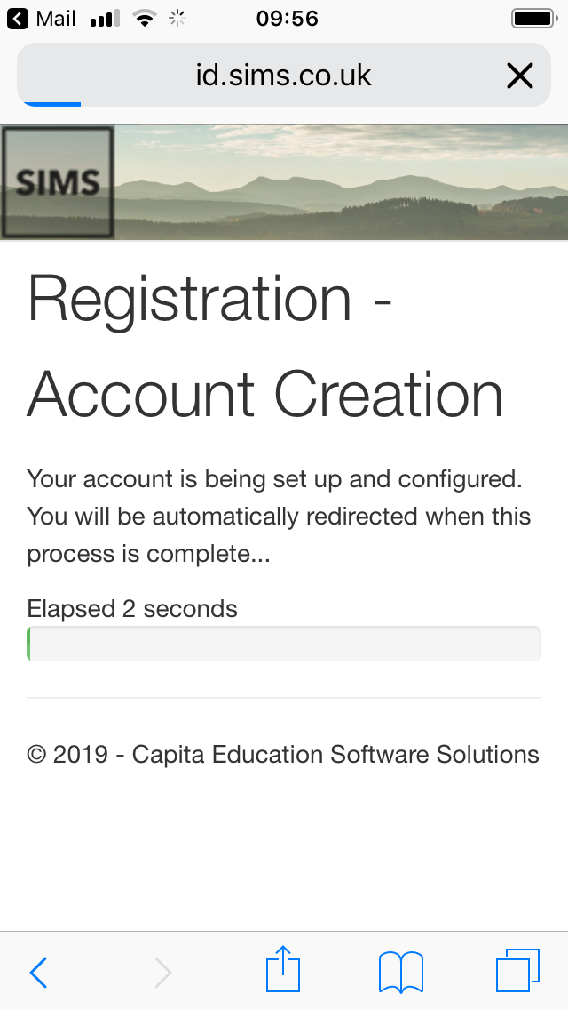

Your account is being created. This should take no longer than 30 seconds. You will be redirected back to the ‘choose an account’ page afterwards.

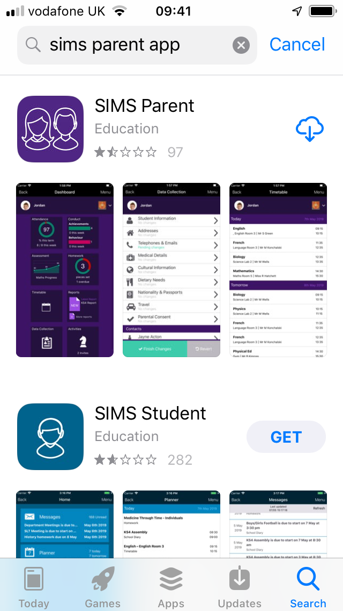

Once registered you can enter the the Sims parent app by downloading this for free via the Apple store, Google play store (Android) or www.sims-parent.co.uk

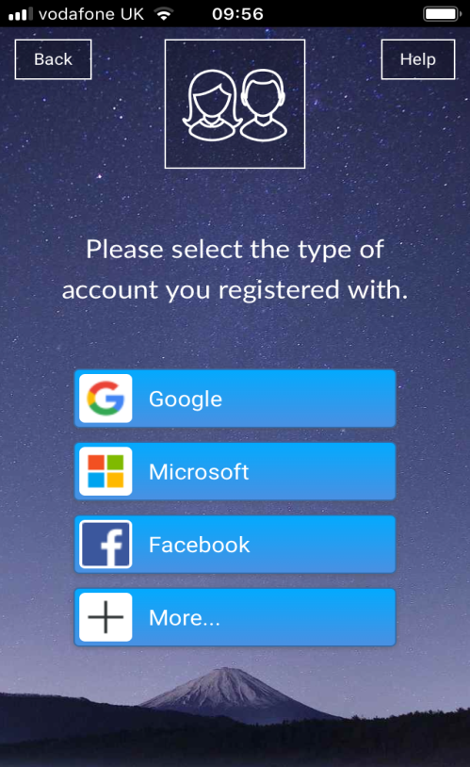
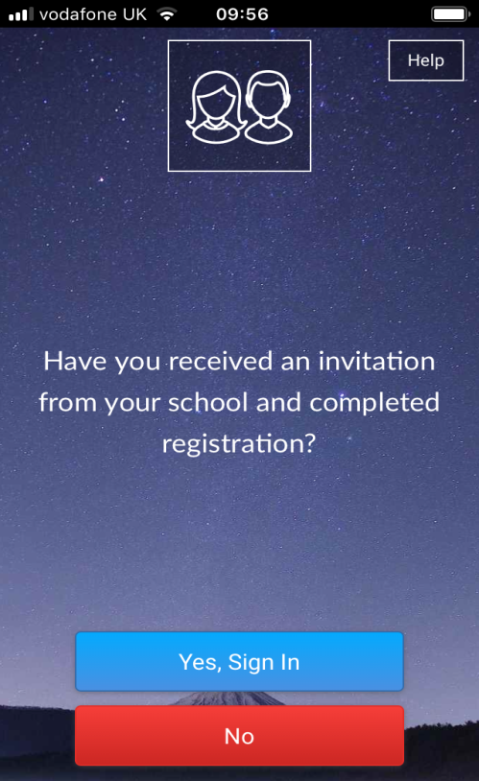

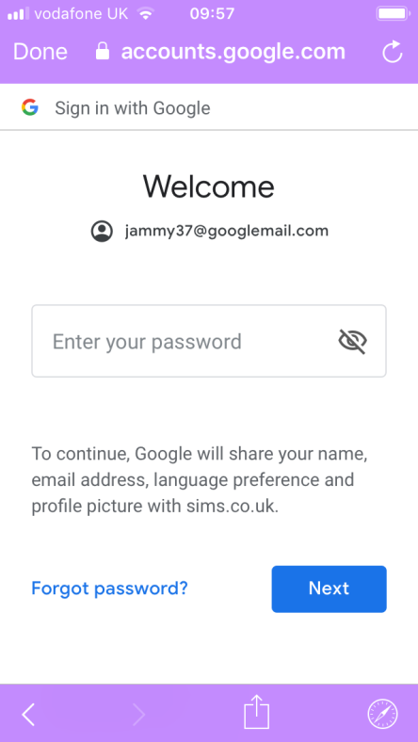
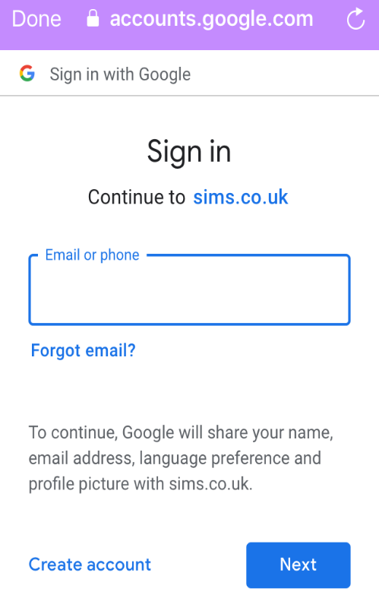

Sign in using the credentials you registered with.

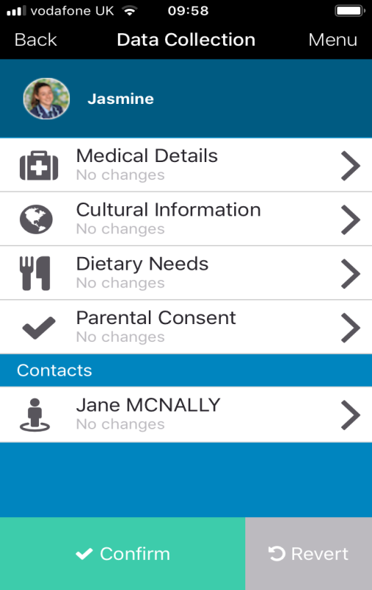
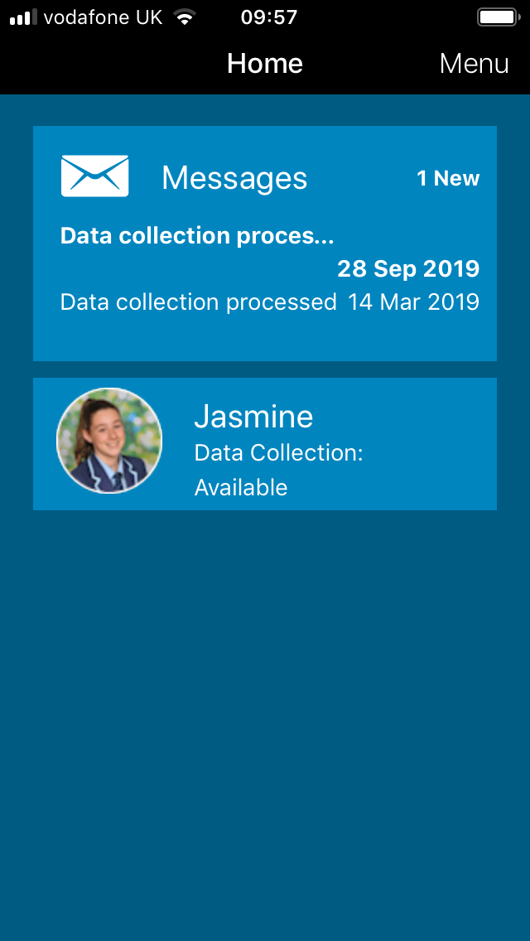

Parents/Guardians can also amend their own details only by clicking on your name. Please make sure you confirm any changes made.
By clicking on your child’s name parents/guardians can amend these details only – Medical details, Cultural information, Dietary needs, and Parental consents.

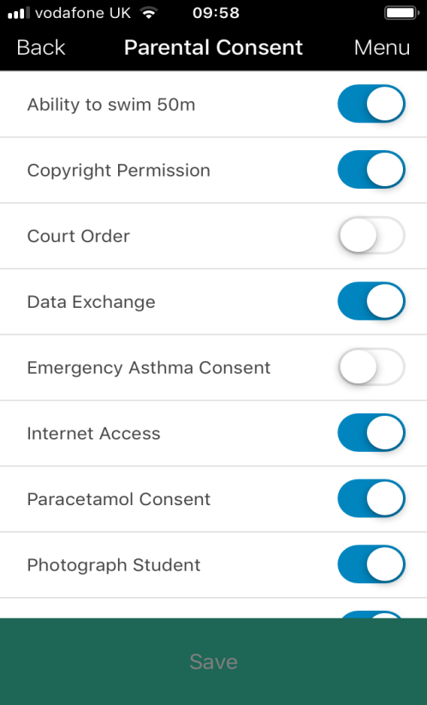

Parents/guardians need to ensure the Academy have the most up to date medical details in case of an emergency.
Please make sure any changes have been saved.

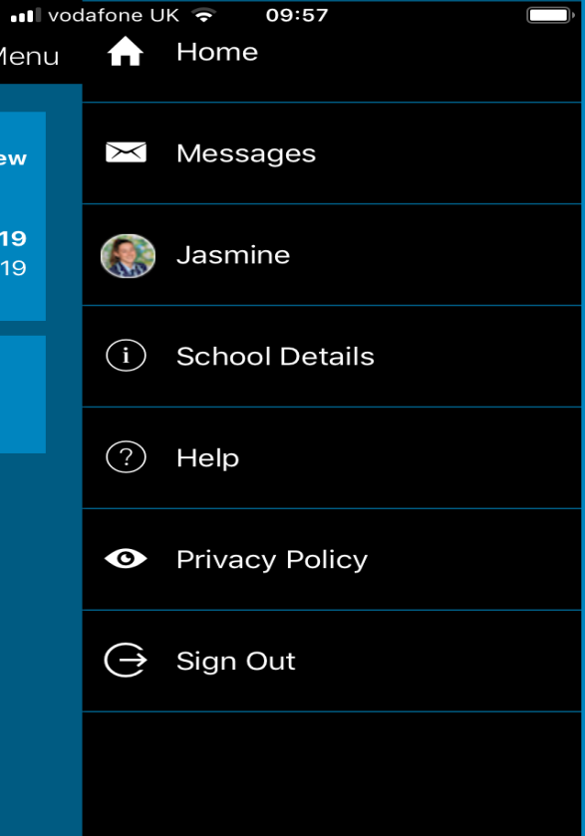
Security - Please be aware that Sims parent will remain active on your device unless you sign out. This can be done by visiting the menu at the top right of the homepage. Please also ensure you have adequate security settings on your device for example a pass code.

Parents/Guardians need to be aware what they are consenting to. Please see below.
School Visit - Parents/Guardians give permission for my child/children to attend the following:
- Academy trips & other activities that take place away from the Academy sites during the school day
- All visits (including residential trips) which take place outside normal Academy hours including weekend and non-term times
- Adventure activities e.g climbing, sailing, canoeing, ten tors
- Offsite sporting fixtures, tournaments & special events both within & outside of the normal Academy hours e.g rugby fixtures and travel between the Borough Road and Waterleat Road sites during the school day and after hours

Photograph Student - Parents/Guardians give permission for their child/children to be photographed/videoed, this includes:
- Academy Promotional and Marketing purposes
- Names being used in documents that can be accessed by members of the public e.g newspaper articles, website or social media
- Academy activities, trips and events
Ability to Swim 50m - Can your child/children swim 50m unaided
Court Order – Is there an active court order regarding your child/children
Emergency Asthma Consent - Parents/Guardians agree to and/or give permission for the following:
- My child has been diagnosed with asthma/has been prescribed an inhaler

- My child can receive salbutamol from an emergency inhaler held by the Academy for such emergencies (possibly displaying symptoms of asthma, and if their inhaler is not available or is unusable)
- My child can receive salbutamol from an emergency inhaler on Offsite Trips and Visits, fixtures and events
- My child has a working in date inhaler, clearly labelled with their name, which they will bring with them to the Academy every day
- I will provide the Academy with my child/children’s Asthma plan completed by their asthma nurse or doctor
Please note that the emergency inhaler can only be used by children who have been diagnosed with asthma & prescribed an inhaler, or who have been prescribed an inhaler for another condition.
Paracetamol Consent - Parents/Guardians agree to and/or give permission for the following:
- Academy staff to administer paracetamol in the event of a headache or other pains

- My child to have the age appropriate dosage as required (quantity)

- I will inform the Academy if my child should no longer take paracetamol

- Academy staff to administer paracetamol within school or offsite (school trip/fixture)

- My child/children are capable of answering, if asked, whether or not they have had a paracetamol product earlier in the day

- I will supply paracetamol if my child requires it regularly

- I will supply paracetamol suspension if that is all my child can take

Internet Access - Parents/Guardians give permission for their child/children to have controlled access to the internet and other information sources on a wide variety of topics for educational purposes only.
Please note: To guard against inappropriate material being accessed intentionally or by accident we use a filtered service provided by the Academy’s broadband provider.
PSHE - Relationships & Sex Education – PSHE can encompass many areas of study. The relationships and health aspects of PSHE education will be compulsory in all schools from 2020. Relationships Education and Relationship and Sex Education is taught as part of broader PSHE education. This way pupils can develop the necessary skills, knowledge and personal attributes as part of a planned programme of regular lessons that also addresses related factors such as media literacy, drugs and alcohol, equality and prejudice and health.

Right to withdraw your child
Parents and carers do not have the right to withdraw from Health Education or the Relationships Education element of Relationships and Sex Education, because it is important that all children receive this content, covering topics such as friendships and how to stay safe.
If parents and carers do not want their child to take part in some or all of the Sex Education lessons they can ask that they are withdrawn. The Head Teacher of Paignton Academy will consider this request and discuss it with the parents and carers, and will grant this in all but exceptional circumstances, up until three school terms before the student turns 16. At this age, the child can choose to receive Sex Education if they would like to, and Paignton Academy will arrange for your child to receive this teaching in one of those three terms (unless there are exceptional circumstances).
The science curriculum in all maintained schools also includes content on human development, including reproduction, which there is no right to withdraw from.
If you wish to find more information about the Sex Education curriculum please look at the details on the school website or contact Jane.craw@paigntonacademy.org . If you feel you have a reason to withdraw your child from the Sex Education part of PSHE, you will need to contact safeguarding@paigntonacademy.org in the first instance, and a meeting will be arranged with the headteacher to discuss your concerns.

Data Exchange and Copyright Permission – Parent/Guardians agree to the following:
The Academy is a registered data controller with the information commissioner and is able to hold data for specific purposes in relation to your child’s education. We have a duty to protect your information and will only hold data relevant to the education and well-being of your child. We will ensure that all data passed to us is reviewed on an annual basis or when any amendments are passed to us. There may be occasions when we are required by law to share data with the relevant local authority or the department for education. This consists mainly of statistical data or information relating to safeguarding and we have an appropriate legal basis to share this information without consent; information on such disclosures can be found on the Department for Education website.
Tetanus – My child/children have an up to date tetanus injection and it is within the 10 year timescale
Emergency Consent - Parents/Guardians give permission for emergency first aid to be administered on my child/children or other urgent medical treatment during any Academy related trip or activity. Please note we would always aim to contact parents in the first instance and only administer if necessary.
If you have any questions or issues regarding Sims Parent Lite, parental consents or are having trouble registering please contact sims@paigntonacademy.org

Useful Questions & Answers:
- How do I download the app?
The SIMS Parent app can be downloaded for free from the Apple Store or the Play Store. Click here for more information
- I can’t find my account registration email. What should I do?
Please check your junk mail and ensure it has not been marked as SPAM. If you still have not received your account registration email, please contact the Academy directly to make sure the correct email address is on the system. sims@paigntonacademy.org

- How do I log in? (Please refer to step by step guide)
Parents will have received an email invitation from the Academy directing them to complete the registration process for Sims Parent Lite.
Parents can access the Sims Parent website by going to https://www.sims-parent.co.uk or via the Sims Parent App.
Once the app is downloaded onto your device, click the icon and this will take you directly to the app.

- I can’t remember my password. What should I do?
Visit the website of your account provider (i.e Microsoft, Google, Facebook or Twitter) and follow their instructions for resetting your password.

- Do I need to register separately for each of my children attending the Academy?
No. When you sign in to Sims Parent Lite you will be able to see all your children displayed in one place.

- Why can’t I access the Sims Parent site or why does the page not load correctly?
Ensure your internet browser is up to date.
If your internet browser is up to date and you are still experiencing problems, please contact the Academy.

- I have signed into Sims Parent lite before but I can’t sign in now. What should I do?
Ensure you are logged in using the correct account (i.e. the account you used during the Sims Parent Lite registration process).
To sign out of an incorrect account, visit the account provider’s website (e.g. Google, Facebook etc.) and sign out.
Close the browser completely. Open a new browser window and log in to Sims Parent, using the account details you used during the registration process.
Alternatively, try accessing Sims Parent Lite through a private browser window; this will ignore any other logged in accounts.
If you still cannot sign in to Sims Parent Lite having followed the advice in this section, please contact the Academy directly.

- Why can’t I open the data collection sheet for my child?
If the data collection sheet is not visible from Sims Parent Lite for your child, you may not meet the criteria required for submitting changes to your child’s account. A registered child contact must live at the same address as the child in order to be eligible to make updates to the data collection sheet.
If you can see the data collection sheet but it is locked (a padlock icon will be displayed) the data collection sheet has been previously submitted and is waiting for the Academy staff to authorise and apply the changes. Once the changes have been applied, the data collection sheet will become available again.

- How do I stop my child’s other contacts seeing my contact details in the data collection sheet?
The Academy has set your contact details as hidden from the other contacts linked to your child’s account. They will not be able to see, amend or access your details.

