Year 9 Extra Curricular Activities
!! EVERYONE WELCOME !!
Activity | When | Where
MONDAY
HUB Club | Lunch | HUB
Astro Free Play | Lunch | Astro-Turf
Dance Mats | Lunch | Coach Ed Room
CVL Netball | After School | HUB
TUESDAY
HUB Club | Lunch | HUB
Astro Free Play | Lunch | Astro-Turf
Girls Football | After School | Astro-turf
Badminton | After School | HUB
WEDNESDAY
HUB Club | Lunch | HUB
Astro Free Play | Lunch | Astro-Turf
Boys Football | After School | Astro-turf
Netball Club | After School | HUB
THURSDAY
HUB Club | Lunch | HUB
Astro Free Play | Lunch | Astro-Turf
Skates Club | Lunch | Sports Hall
FRIDAY
HUB Club | Lunch | HUB
Astro Free Play | Lunch | Astro-Turf
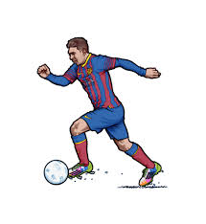
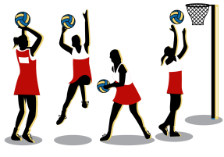
Lunchtime clubs run from
1:15-1.45pm
After School activities run
from 3-4pm

Hub Club – Activities in the HUB – PLEASE WEAR TRAINERS
Astroturf – free play - MUST WEAR SHINPADS AND TRAINERS OR FOOTBALL BOOTS WITH ROUND MOULDED STUDS (NO METAL STUDS/BLADES)

