Year 8 Extra Curricular Activities
!! EVERYONE WELCOME !!
Activity | When | Where
MONDAY
Astro Free Play | Lunch | Astro-turf
HUB Club | Lunch | HUB
Dance Mats | Lunch | Coach Ed Room
CVL Netball | After School | HUB
TUESDAY
Astro Free Play | Lunch | Astro-turf
HUB Club | Lunch | HUB
Girls Football | After School | Astro-turf
Badminton | After School | HUB
WEDNESDAY
Astro Free Play | Lunch | Astro-turf
HUB Club | Lunch | HUB
Boys Football | After School | Astro-turf
Netball Club | After School | HUB
THURSDAY
Astro Free Play | Lunch | Astro-turf
HUB Club | Lunch | HUB
Skates Club | Lunch | Sports Hall
FRIDAY
Astro Free Play | Lunch | Astro-turf
HUB Club | Lunch | HUB
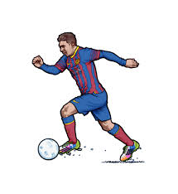
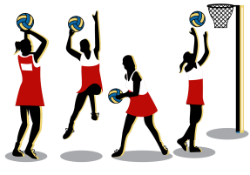
Lunchtime clubs run from
1:15-1.45pm
After School activities run
from 3-4pm

Hub Club – Activities in the HUB – PLEASE WEAR TRAINERS
Astroturf – free play - MUST WEAR SHINPADS AND TRAINERS OR FOOTBALL BOOTS WITH ROUND MOULDED STUDS (NO METAL STUDS/BLADES)

