Year 7 Extra Curricular Activities
!! EVERYONE WELCOME !!
Activity | When | Where
MONDAY
Free Play | Lunch | Field
Astro Free Play | Lunch | Astro-turf
HUB Club | Lunch | HUB
CVL Netball | Afterschool | HUB
All Years Boys and Girls Basketball | Afterschool | Sports Hall
TUESDAY
Astro Free Play | Lunch | Astro-turf
Touch Rugby | Lunch | Astro-turf
HUB Club | Lunch | HUB
Dodgeball | Afterschool | Gym
Girls Football | Afterschool | Astro-turf
Badminton | Afterschool | HUB
WEDNESDAY
Astro Free Play | Lunch | Astro-turf
HUB Club | Lunch | HUB
Boys Football | Afterschool | Astro-turf
Netball Club | Afterschool | HUB
THURSDAY
Astro Free Play | Lunch | Astro-turf
HUB Club | Lunch | HUB
Girls Rugby Training | Afterschool | Field
Boys Rugby Training | Afterschool | Field
FRIDAY
Astro Free Play | Lunch | Astro-turf
HUB Club | Lunch | HUB
Girls Skates Club | Lunch | Sports Hall
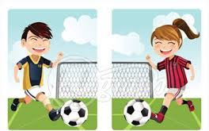
Lunchtime clubs run from 1:15 - 1.45pm
After School activities runs from 3-4pm

