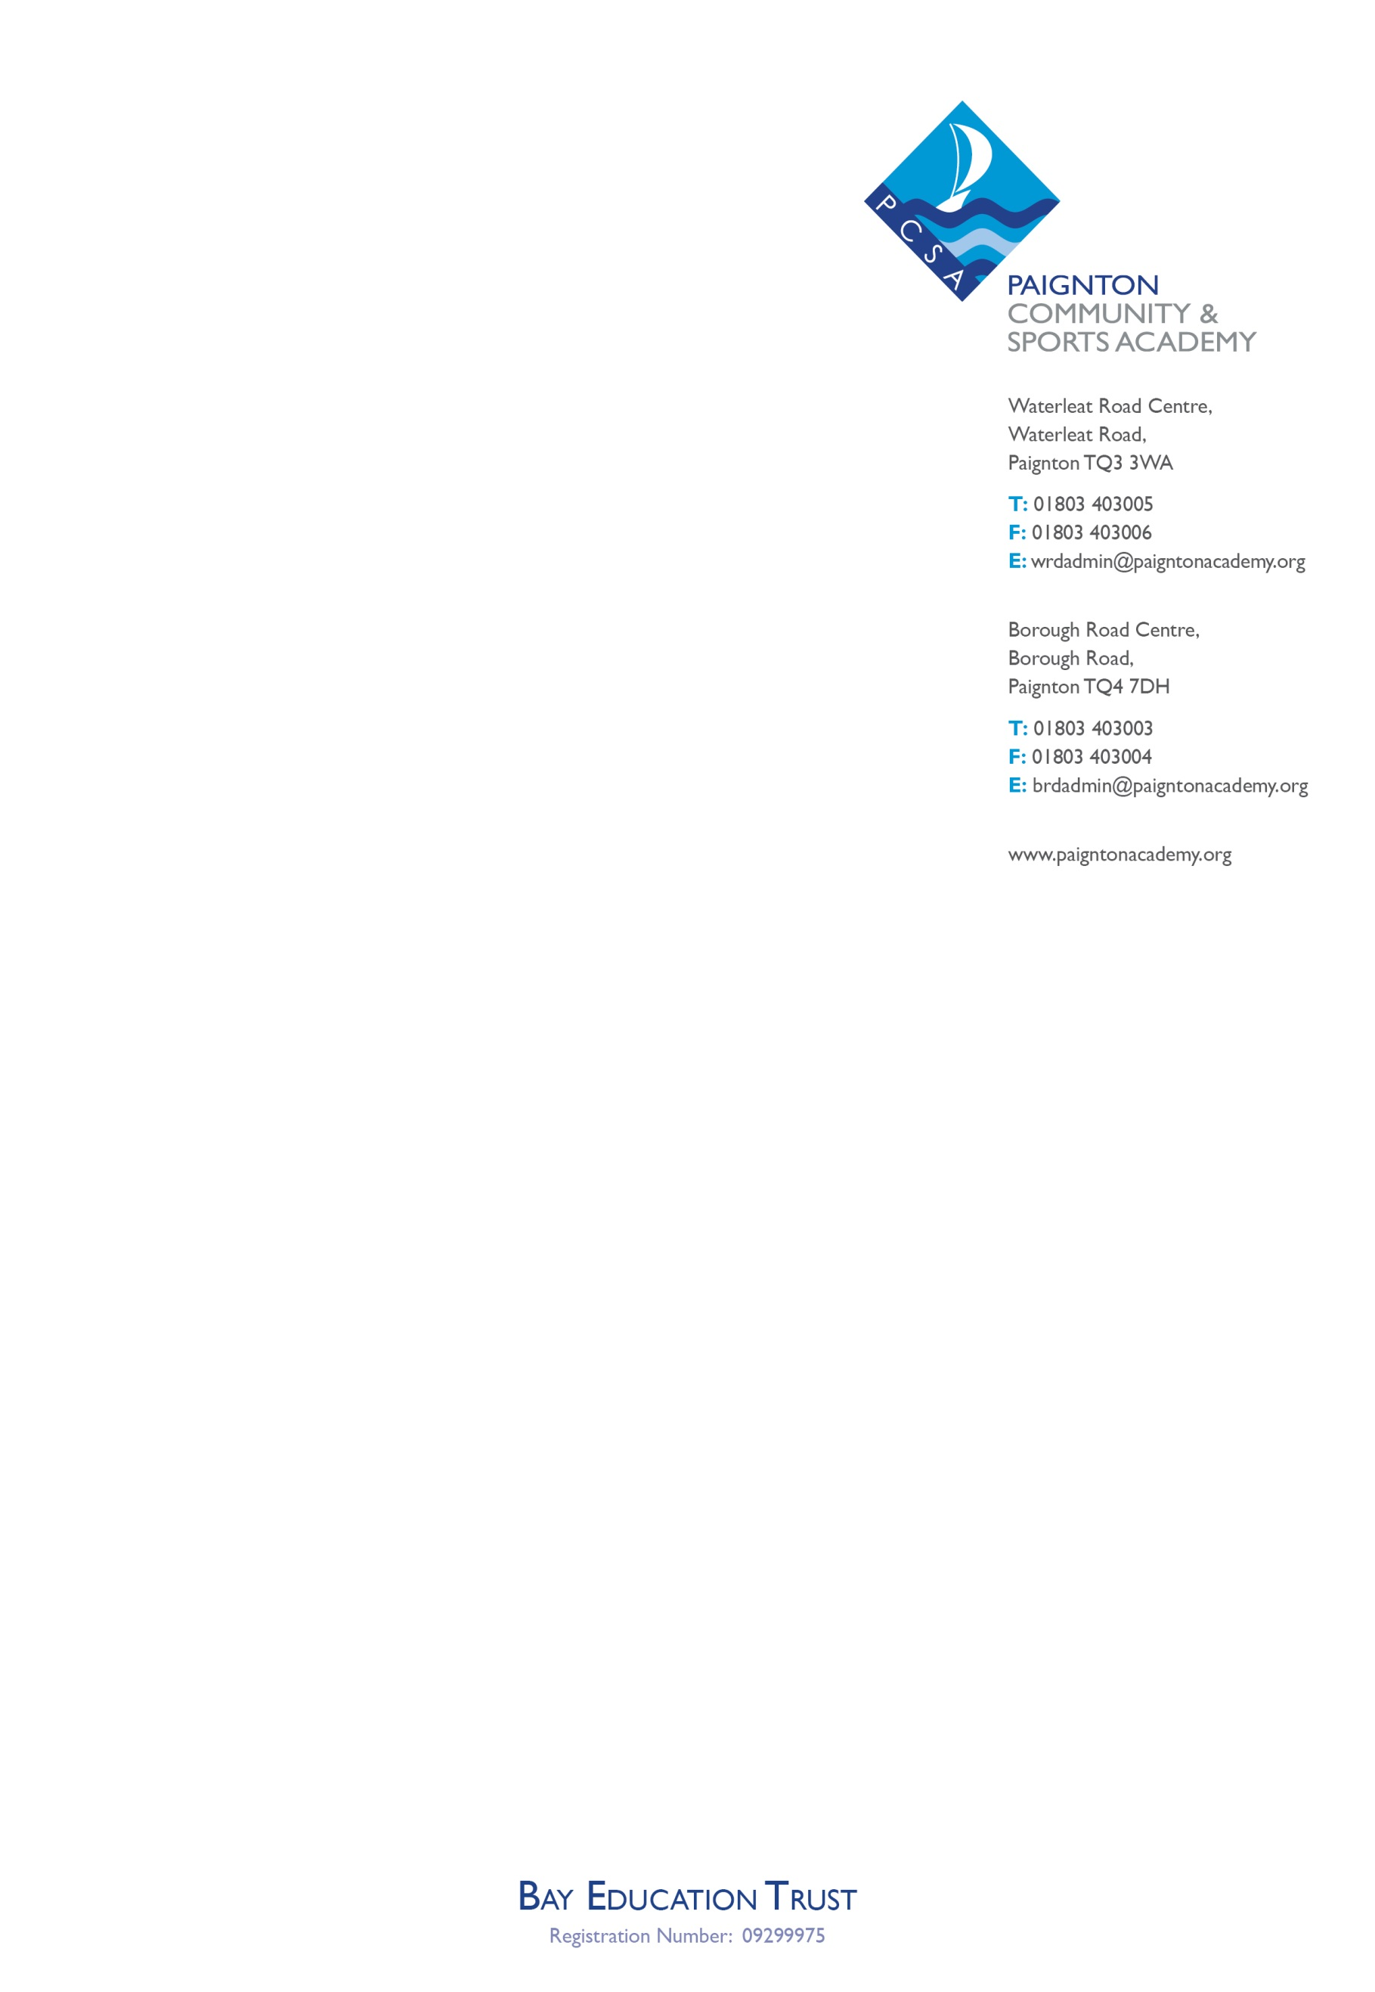
Date:
Our Ref: Medical evidence letter
Reply to: Mr Michael Bissett
At: Waterleat Road

Address

Dear Parent

Re: Absences from school.

I am writing to you regarding (Student Name)’s attendance to school since the start of the current academic year; To date the Academy has received calls/texts from you to confirm the reason for absence but as per Academy Policy we will now require supporting evidence that there is a genuine medical reason for (Student Name) to be absent from school in the future. The Policy states:

Illness:
Medical evidence may be requested where a child has been absent for 4 consecutive days or more due to illness OR where a child’s attendance is below 90% and/or is regularly away from school due to illness. Failure to provide evidence when requested may result in the absences being unauthorised.

The following forms of evidence are accepted:
- A doctor’s certificate or letter
- A signed and dated appointment card from the doctor’s surgery showing that you attended an appointment
- A copy of a prescription relating to the illness
- Medication packaging with the child’s name on and the date issued

In situations where a child accumulates 10 or more unauthorised absences (the equivalent of 5 school days) within any six month period, parents/carers will make themselves liable to receiving a Penalty Notice per parent/carer, per child from Torbay Council.

The Penalty Notice carries a penalty of £60 if paid in full within 21 days or £120 if paid in full after this time but within 28 days. If a Penalty Notice goes unpaid, this is likely to result in Court proceedings being taken against you for an offence of failing to ensure regular school attendance contrary to section 444 Education Act 1996. If convicted, you may face a fine of up to £2500 and/or a maximum 3 months imprisonment.

I am sure you will do your upmost to ensure your child is not absent from school unnecessarily; if there is any support that we can provide you with, please do not hesitate to contact me.

Yours sincerely

Mr Michael Bissett, Attendance & Welfare Officer

