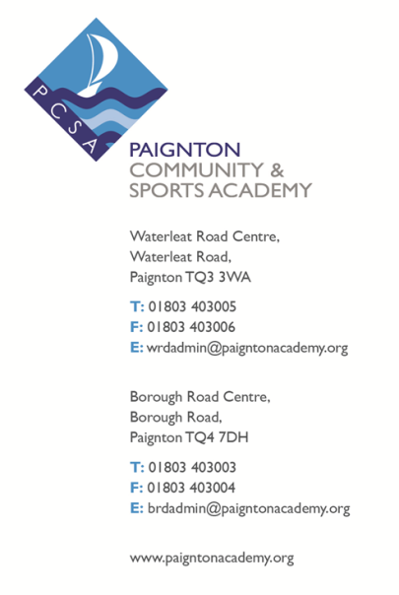
Date: June 2018
Our Ref: Year 9 examinations
Reply to: ALF/JXB
At: Waterleat Road

Dear Parents/Guardians,
I am writing to inform you that Year 9 will be taking their final set of exams during the week beginning the 9th July 2018. The Core subjects will be in the Sports Hall and all other exams will take place in classrooms. This will be another opportunity this year for students to have crucial practice in a formal situation for their GCSE exams before they enter Year 10. The new style GCSEs are far more demanding than they have been in the past, so these exams will give students a real understanding of how hard they will need to work to be successful in their final GCSE exams.
It is essential that Year 9 start their revision for these exams now. Students will be given a comprehensive revision guide with important advice and guidance from each individual subject. All information about these exams, including the revision guide, will be on the Academy website. The Waterleat Road Library is also open after school from 3pm to 4pm Monday – Thursday to support student’s learning, as well as from 8am – 8.30am every morning.
It is important that the students take these examinations seriously, as the results of these exams will inform the staff and the students of their current grade, and more importantly what they need to do to improve so that they can reach or exceed their target grades at GCSE. The results from these exams will be sent home and will be reported using the new 1 – 9 grading system and using the BTEC Pass, Merit & Distinction criteria.
I am also attaching the exam timetable, although students will also receive their own individual timetables nearer the time.
If you have any questions regarding the exams, please do not hesitate to contact me on progress@paigntonacademy.org. Yours faithfully,

Anne Freeman (Assistant Head of School – Progress)

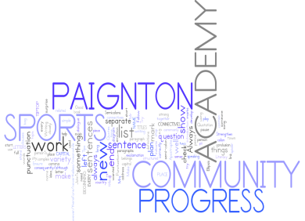

Year 9 examinations

Week beginning 9th July 2018

GENERAL REVISION ADVICE

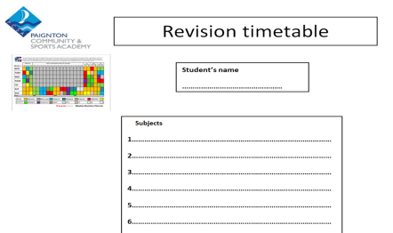
1. Make a revision timetable so that you can plan your revision.

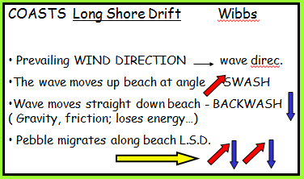
2. Try different ways of revising:
Mind maps
Doddle
Flashcards
Highlight key words – reduce your notes
Revision apps/websites

3. BUG the question in the exams:
BUBBLE command words
UNDERLINE key points
GLANCE back

4. Find out from your teacher what a model answer looks like so that you can reach your target grade.

5. Spend at least an hour on revision each night.
1 hour on revision per night

6. Attend all revision sessions available to you.

7. Turn off all mobile devices whilst revising!
8. Get plenty of sleep before your exam and eat well.

9. Make sure that you have all the equipment you need for each
exam.

10.

NB
All Option exams will be in lesson time. The subjects are:
French
Geography
History
Computer Science
Music
Drama (practical)

Year 9 Examinations

Week beginning 9th July 2018

English
Format of the exam:
The exam is one hour long and is closely linked to GCSE Edexcel Paper 2 Section A. You will be asked to read two different nonfiction extracts and you will have to answer a series of comprehension questions about them.
Topics that need to be revised:
- Locating and identifying information from a text.
- Inferring information from a text.
- Explaining how language is used to create an effect on the reader.
- Explaining how structure is used to create an effect on the reader.
- Developing an explanation of the effect of individual words within a sentence.
- Structuring ideas into a logical sequence.
- Explaining the similarities between texts.
- Comparing texts.
- Exploring how successful the writer is in expressing their ideas.
Hints and tips for preparation:
Use the revision information on Paignton online. Work through the tasks as they are very similar to the tasks in the exam.
Practice identifying key quotes in a short space of time. Set yourself a target of 4 quotes in 3 minutes and then try to explain their effect. Identify key words in the quotes. Ask yourself, why has the author chosen to use this specific word? What are they trying to suggest to the reader?
Read nonfiction texts and consider the writer’s use of structure. What kind of sentences are used to create a certain effect and why? From what perspective is it written?
Check back through your English exercise books and read your teacher feedback closely. Identify the areas that you need to improve on. What spelling, punctuation and grammar mistakes do you make? How can you avoid losing marks in the exam?
Think about the different word groups and why the writer may have chosen to use those specific words.

Stretch and challenge for top grades:

Focus on developing and extending your explanation of quotes. Think about identifying single words within the quote and drawing together your comments on how the language contribute to the overall effect on the reader.

Try to make your explanation of the impact on the reader as specific and focused as possible. Always explain HOW the impact is achieved.

Analyse the ideas and perspectives including how the theme, language and structure are used across the texts.

Year 9 Examinations

Week beginning 9th July 2018

Mathematics

Format of the exam:
There will be two papers, one calculator and one non-calculator. Students will aim to complete all of the questions. Each paper is 75 minutes in length. There are two tiers of papers, Foundation and Higher.
Topics that need to be revised:
The papers are GCSE questions based on topics that have been covered throughout the Year 9 curriculum. Students should focus their revision on calculations, expressions, angles and polygons, handling data, fractions decimals and percentages, formulae and functions and working in 2D.
Hints and tips for preparation:
- Make sure you have looked at every topic and not just your favourites
- Revise a little and often. Rather than two hours the night before the exam pick a topic and spend 30mins looking through revision material every other night
- Make revision active – reading things will only help a little bit; make sure you give yourself time to do and understand examples
- Make use of the online support as it will support your learning

Useful websites & where to find help:
The maths team will run lunchtime drop-in classes for revision with sample questions. These run from 1pm to 1:30pm in room W19. Maths are running revision after school on Wednesdays.
www.hegartymaths.com. Please register for a free account then select KS3 and Key Stage 3. Selecting from the four main topic areas provides for individual topic revision.
www.mymaths.co.uk (username: paignton password: pyramid. Use the search tool to look up each of the areas)
http://www.bbc.co.uk/education/subjects/zqhs34j (select topics from the menu)
Google classrooms – frequent check-ins for current topics as you progress through your GCSE course.
www.mrbartonmaths.com. An excellent free website with lots of useful resources
Year 9 Examinations

Week beginning 9th July 2018

Science
Format of the exam:
1 60 minute exam paper
50% knowledge questions
20% data analysis questions
30% applying knowledge questions (QWC)
This transition test aims to highlight gaps in students’ knowledge from year 7 & 8 so we are able to tailor the year 9 GCSE course to their needs.
Topics that need to be revised:
Chemistry:
C1 Atomic Structure & The Periodic Table

C2 Structure and Bonding
Biology:
B1 Cell Biology
B4 Bioenergetics
Physics:
P6 The Particle Model of Matter
P7 Radioactivity

Hints and tips for preparation:
Be sure to read all of the questions carefully and use the B.U.G system (BOX command words, UNDERLINE keywords, GLANCE back at the question).
Re-read a question if you are unsure of what it is asking.
Make an educated guess rather than leaving blank spaces.
If a question is worth 6 marks, make at least 6 points.
Put a * next to a question if you are stuck and return to it at the end once you have got to the end of the test.
Double check data questions as often the answer is within the question.
Make sure you have looked at every topic and not just your favourites.
Revision should be conducted little and often. It is much more productive to spend 30 minutes revising each night as opposed to doing 4 hours revision just before the assessment.
Make revision active – reading material/content will only help a little bit. Make sure you be creative with revision. You might want to create post-it notes, revision Mindmaps or videos etc.

Stretch and challenge for top grades:
Pupils should be able to apply their knowledge to real life examples.
Demonstrate an understanding of trends of the periodic table
Demonstrate an understanding of ethical issues of stem cells.

Useful websites & where to find help:

http://www.aqa.org.uk/subjects/science/gcse/combined-science-trilogy-8464

http://www.aqa.org.uk/subjects/science/gcse/biology-4401

http://www.aqa.org.uk/subjects/science/gcse/chemistry-8462

http://www.aqa.org.uk/subjects/science/gcse/physics-4403

http://www.bbc.co.uk/schools/gcsebitesize/

Year 9 Examinations

Week beginning 9th July 2018

Geography
Format of the exam:
The exam will be taken in lesson time and will have an allocated time of 50 minutes. There will be two sections of the exam paper. Section A will cover development in particular how economic development can provide opportunities and challenges in countries. Section B will cover natural hazards; in particular volcanoes and earthquakes. The paper will reflect elements of the AQA Geography GCSE papers.
There will be 3 additional marks for SPaG (Spelling, Punctuation and Grammar).

Topics that need to be revised:
Section A: Development
Key vocabulary and abbreviations e.g. (NEE, HIC, LEE, development indicators)
Factors that influence a country’s rate of economic development
Case studies – Opportunities for China’s population and challenges in Brazil’s favelas
Section B: The Restless Earth
Plate boundaries
Advantages and disadvantages of living near a volcano
Primary and secondary effects of earthquakes
Planning and preparing for natural hazards
A case study for a volcanic eruption or earthquake – cause, effects, impacts.

Hints and tips for preparation:
Write a revision time table and plan when you are going to complete your revision. You have a lot to revise.
Be active in your revision methods – mind maps, key facts cards etc.
Paignton Online.
Stretch and challenge for top grades:
You must use connectives to explain points and answer case studies with extended writing to access the higher grades.
Useful websites & where to find help:
Paignton Revision Hub (found at the bottom of the Academy’s website will have links to everything you need!) Work will be assigned to you all on Doddle and Class Charts.
Year 9 Examinations

Week beginning 9th July 2018

History
Format of the exam:
Quick knowledge questions.
Summary paragraphs.
Full essay question.

Topics that need to be revised:
Crime and Punishment 1250-Modern.

Hints and tips for preparation:
- Revise the key terms and dates. Check that you know which types of crimes and punishments, and also law enforcement took place in each of the different time periods.
- Practice APE/PEE for your essay questions.
- Use BUG and remain focussed on what the question asks you to do.
Stretch and challenge for top grades:
- Try to memorise a short quote about one of the above topics to enhance your writing.
- Go DEEP (dates, example, event, people) and include key words.

Useful websites & where to find help:
Paignton Online
BBC Bitesize

Year 9 Examinations

Week beginning 9th July 2018

Computer Science
Format of the exam:
45 minute paper.
24 marks in total.
The questions will be made up of short answer, multiple choice and long
answer questions.

Topics that need to be revised:
Inputs and Outputs
Hardware
Software
Binary, Denary and Hex
Logic

Hints and tips for preparation:
Look through all of the work you have doing on GOOGLE Classroom.
Focus on your end of topic tests and the areas that you got wrong and make sure you are clear how to answer these questions now.

Stretch and challenge for top grades:
The binary, denary and hex topic is usually one students find tough, especially converting to Hex. Please practice Binary, Denary and Hex conversions.

Useful websites & where to find help:
Google Classroom for all activities and end of topic tests.

Year 9 Examinations

Week beginning 9th July 2018
French

Format of the exam:
1 hour written exam in class

Topics that need to be revised:
- Home and local area
- Extended opinions.
- Time expressions.
- Negatives.
- Connectives.
- Grammar: 3 tenses: near future, past and present.
Hints and tips for preparation:
Practise making sentences and paragraphs in preparation for this exam. Your teacher will advise you and guide you on this. Learn vocabulary and the grammar structures so that you can demonstrate the skills you have learned.

Stretch and challenge for top grades:
Checking for accuracy is essential and being disciplined in reviewing your answers and being prepared to modify them is also key. You should be an expert in tenses, connectives, explained opinions, negatives as well as being able to demonstrate complex structures.

Useful websites & where to find help:
www.linguascope.com

Year 9 Examinations

Week beginning 9th July 2018
Music

Format of the exam:
The music exam is a 1 hour written exam.

Topics that need to be revised:
Students should revise the topics covered since the beginning of the school year: Jazz, Pop, Musical arrangements and Film. Be sure to revise the keywords, chords, notes and instrumentation used in each topic. Be prepared to evaluate your own performance techniques.

Hints and tips for preparation:
Use the internet to search keywords and topics covered, especially BBC Bitesize’s section on music.
Also, look back over information and home learning covered in your folders, and also any Doddle home learning covering the topics.
Be sure to speak to Mrs Bidder about anything you are unsure of.

Stretch and challenge for top grades:
To reach the top grades you will need to be aware of exam format, thoroughly revise the topics covered and to make sure you write in enough detail giving examples where possible.

Useful websites & where to find help:
BBC Bitesize Music – search for the topics covered.

