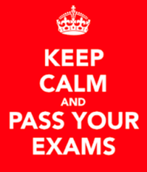
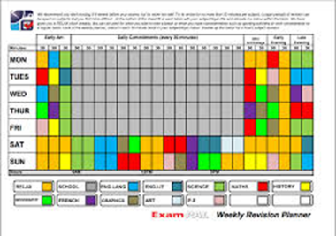
Revision timetable
Student’s name
…………………………………………

Subjects
1……………………………………………………………………………………
2……………………………………………………………………………………
3……………………………………………………………………………………
4……………………………………………………………………………………
5……………………………………………………………………………………
6……………………………………………………………………………………
7……………………………………………………………………………………
8……………………………………………………………………………………
9……………………………………………………………………………………
10……………………………………………………………………………………

RAG your subjects:
Red (Not confident)
Amber (Quite confident)
Green (Confident)

Date | Subjects for revision/Time needed |  | Exam dates/Info
Monday 26th March
Tuesday 27th March
Wednesday 28th March
Thursday 29th March |  |  | Easter Holidays
Friday 30th March |  |  | Easter Holidays
Saturday 31st March |  |  | Easter Holidays
Sunday 1st April |  |  | Easter Holidays
Monday 2nd April |  |  | Easter Holidays
Tuesday 3rd April |  |  | Easter Holidays
Wednesday 4th April |  |  | Easter Holidays
Thursday 5th April |  |  | Easter Holidays
Friday 6th April |  |  | Easter Holidays
Saturday 7th April |  |  | Easter Holidays
Sunday 8th April |  |  | Easter Holidays
Monday 9th April |  |  | Easter Holidays
Tuesday 10th April |  |  | Easter Holidays
Wednesday 11th April |  |  | Easter Holidays
Thursday 12th April |  |  | Easter Holidays
Friday 13th April |  |  | Easter Holidays
Saturday 14th April |  |  | Easter Holidays
Sunday 15th April |  |  | Easter Holidays
Monday 16th April |  |  | Easter Holidays
Tuesday 17th April
Wednesday 18th April
Thursday 19th April
Friday 20th April
Saturday 21st April
Sunday 22nd April
Monday 23rd April
Tuesday 24th April
Wednesday 25th April
Thursday 26th April
Friday 27th April
Saturday 28th April
Sunday 29th April
Monday 30th April
Tuesday 1st May
Wednesday 2nd May |  |  | French speaking exams
Thursday 3rd May |  |  | French speaking exams
Friday 4th May |  |  | French speaking exams
Saturday 5th May
Sunday 6th May
Monday 7th May |  |  | Bank Holiday
Tuesday 8th May
Wednesday 9th May
Thursday 10th May
Friday 11th May
Saturday 12th May
Sunday 13th May
Monday 14th May |  |  | Computer Science (am)
Tuesday 15th May |  |  | French List/Reading (am)  Biology Paper 1 (pm)
Wednesday 16th May |  |  | Ethics (pm)
Thursday 17th May |  |  | Chemistry Paper 1 (am)
Friday 18th May |  |  | French writing (am)  Drama (pm)
Saturday 19th May
Sunday 20th May
Monday 21st May |  |  | Leisure & Tourism (pm)
Tuesday 22nd May |  |  | English Lit Paper 1 (am)  Geography Paper 1 (pm)
Wednesday 23rd May |  |  | Business Studies (am)  Physics paper 1 (pm)
Thursday 24th May |  |  | Maths Paper 1 (am)
Friday 25th May |  |  | English Lit Paper 2 (am)  Final day!!
Saturday 26th May
Sunday 27th May
Monday 28th May |  |  | Half-term
Tuesday 29th May |  |  | Half-term
Wednesday 30th May |  |  | Half-term
Thursday 31st May |  |  | Half-term
Friday 1st June |  |  | Half-term
Saturday 2nd June
Sunday 3rd June
Monday 4th June |  |  | History (am)  Media (pm)
Tuesday 5th June |  |  | English Language 1 (am)  Geography Paper 2 (pm)
Wednesday 6th June
Thursday 7th June |  |  | Maths Paper 2 (am)
Friday 8th June |  |  | English Language 2 (am)  History (pm)
Saturday 9th June
Sunday 10th June
Monday 11th June |  |  | Biology Paper 2 (am)  Geography (pm)
Tuesday 12th June |  |  | Maths Paper 3 (am)
Wednesday 13th June |  |  | Chemistry Paper 2 (am)  Health & Social Care (pm)
Thursday 14th June |  |  | Child Development (am)  Food (pm)
Friday 15th June |  |  | Physics Paper 2 (am)
Saturday 16th June
Sunday 17th June
Monday 18th June |  |  | General Studies (pm)
Tuesday 19th June
Wednesday 20th June |  |  | General Studies (am)
Thursday 21st June |  |  | End of exams!!!!!!

