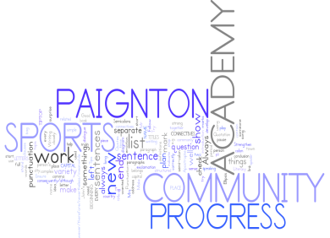
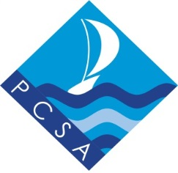

Year 8 examinations

Week beginning 23rd April 2018

GENERAL REVISION ADVICE

1. Make a revision timetable so that you can plan your revision.
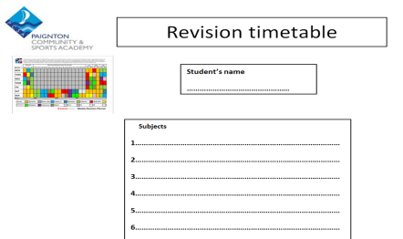

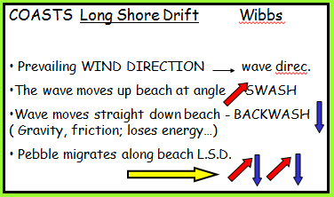
2. Try different ways of revising:
Mind maps
Doddle
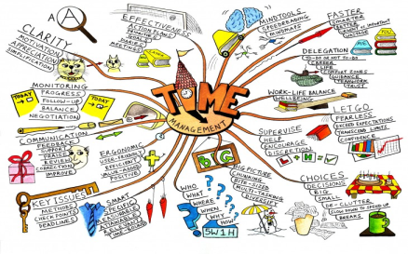
Flashcards
Highlight key words – reduce your notes
Revision apps/websites

3. BUG the question in the exams:
BUBBLE command words
UNDERLINE key points
GLANCE back

4. Find out from your teacher what a model answer looks like so that you can reach your target grade.

5. Spend at least an hour on revision each night.
1 hour on revision per night

6. Attend all revision sessions available to you.

7. Turn off all mobile devices whilst revising!
8. Get plenty of sleep before your exam and eat well.

9. Make sure that you have all the equipment you need for each
exam.

10.

Year 8 examinations

Week beginning 23rd April 2018

English
Format of the exam:
Useful websites & where to find help:
http://www.bbc.co.uk/bitesize/standard/english/lit_form/newspaper/revision/1/
http://www.bbc.co.uk/bitesize/ks3/english/writing/structure_paragraphs/revision/2/

The exam is one hour long and is closely linked to GCSE Edexcel Paper 2 Section A. You will be asked to read two different nonfiction extracts and you will have to answer a series of comprehension questions about them.
Topics that need to be revised:
- Locating and identifying information from a text.
- Inferring information from a text.
- Explaining how language is used to create an effect on the reader.
- Explaining how structure is used to create an effect on the reader.
- Developing an explanation of the effect of individual words within a sentence.
- Structuring ideas into a logical sequence.
- Explaining the similarities between texts.
- Comparing texts.
- Exploring how successful the writer is in expressing their ideas.
Hints and tips for preparation:
Use the revision information on Paignton online working through the tasks as they are very similar to the tasks in the exam.
Practice identifying key quotes in a short space of time. Set yourself a target of 4 quotes in 3 minutes and then try to explain their effect. Identify key words in the quotes. Ask yourself, why has the author chosen to use this specific word? What are they trying to suggest to the reader?
Check back through your English exercise books and read your teacher feedback closely. Identify the areas that you need to improve on. What spelling, punctuation and grammar mistakes do you make? How can you avoid losing marks in the exam?
Think about the different word groups and why the writer may have chosen to use those specific words.

Stretch and challenge for top grades:

Focus on developing and extending your explanation of quotes. Think about identifying single words within the quote and drawing together your comments on how the language contribute to the overall effect on the reader.

Try to make your explanation of the impact on the reader as specific and focused as possible. Always explain HOW the impact is achieved.

Year 8 examinations

Week beginning 23rd April 2018

Mathematics
Format of the exam:
There will be one 60-minute, non-calculator, exam paper to complete.

Students will attempt all the questions. The paper has been designed to challenge students and it is unlikely that the majority of students will finish the paper. This will stretch students and provide them with the opportunity to demonstrate the depth of their learning.

There are two tiers of paper. There will be a foundation tier for students with targets of Remembering, Understanding and Applying and a higher tier paper will be for students with targets of Analysing, Evaluating and Creating. There will be 60 marks available and as a rough guide, students should attempt to complete a 1-mark question every 1 minute.

Topics that need to be revised:
The paper will cover the following topics that have been taught this academic year.
- Whole numbers and decimals (Number)
- Number calculations (Number)
- Fractions, decimals and percentages (Number)
- Expressions (Algebra)
- Equations (Algebra)
Hints and tips for preparation:
- Make sure you have looked at every topic and not just your favourites
- Revise a little and often. Rather than two hours the night before the exam pick a topic and spend 30 mins looking through revision material every other night
- Make revision active – reading things will only help a little bit; make sure you give yourself time to do and understand examples
- Make use of the online support as it will support your learning
Stretch and challenge all grades:
Each of the Foundation and Higher tier papers will enable students to show the depth of their learning. For the majority of students, it will be a challenge to complete all the questions within the hour.
Useful websites & where to find help:
The maths team will run lunchtime drop-in classes for revision with sample questions. These run from 1:15 pm to 1:45 pm in room W20.
www.hegartymaths.com. Please register for a free account then select KS3 and Key Stage 3. Selecting from the four main topic areas provides for individual topic revision.
www.mymaths.co.uk (username: paignton; password: pyramid. Use the search tool to look up each of the areas)
http://www.bbc.co.uk/education/subjects/zqhs34j (select topics from the menu)
Google classrooms – frequent check-ins for current topics as you progress through your GCSE course.
www.mrbartonmaths.com. An excellent free website with lots of useful resources.

Year 8 examinations

Week beginning 23rd April 2018

Science
Format of the exam:
50% knowledge questions
20% data analysis questions
30% applying knowledge questions

Topics that need to be revised:
Biology:
Unit 8.3 Breathing
Unit 8.4 Digestion
Unit 9.3 Interdependence (Respiration)
Unit 9.4 Photosynthesis

Chemistry:
Unit 5.3 Elements
Unit 5.4 Periodic Table
Unit 6.3 types of reactions
Unit 6.4 Chemical Energy

Physics:
Unit 1.3 Contact Forces
Unit 1.4 Pressures
Unit 2.3 Magnetism
Unit 2.4 Electromagnets

Hints and tips for preparation:
Be sure to read all questions properly and use the B.U.G system (Box command words, Underline keywords, Glance back at the question).
Ensure to use pencil and ruler where needed.
Double check data questions as often the answer is within the question.

Stretch and challenge for top grades:
Be able to draw particle diagrams of element and compounds
Be able to know the symbols of the following elements: carbon, oxygen, copper, magnesium, sulphur, iron, gold, aluminium, silver, hydrogen and nitrogen.
Be able to write balanced word equations for chemical reactions.
Be able to use units of measurement when describing forces.

Useful websites & where to find help:
BBC bite size – KS3- search units above
www.kerboodle.com AQA Activate

Year 8 examinations

Week beginning 23rd April 2018

Geography

Format of the exam:
There will be three sections of the exam paper for which you have 1 hour to answer all the questions. There will be one section on rivers, one on coasts and one on urban geography.
Topics that need to be revised:
Coasts
- Rivers – the three courses, a river profile, the drainage basin, erosion and deposition.
- Coasts – landforms as a result of erosion and transportation e.g. the formation of a stump, coastal management strategies (sea defences)
- Urban geography – megacities, push and pull factors, problems in urban areas.
Hints and tips for preparation:
Write a revision time table and plan when you are going to complete your revision.
Be active in your revision methods – mind maps, key facts cards, quizzes with a friend, watch YouTube revision material.
Use the material on Paignton Revision Hub, Doddle and attached documents on Class Charts.
Ask for help if you still do not understand something!

Stretch and challenge for top grades:
The exam paper is styled on previous GCSE examination questions and will be marked using GCSE criteria and grade boundaries. There are a combination of lower and higher mark questions. These higher mark questions will need structured paragraphing, connectives used to extend detail and excellent SPaG and key vocabulary to achieve top marks.

Useful websites & where to find help:
- Doddle – your teacher will assign you dozens of tasks – work through the topics you are unsure of the most and ask for help if you still do not understand something!
- Class charts will have weekly revision tasks leading up until your exam
- Paignton Revision Hub has many links and YouTube clips to watch
- Bitesize is an excellent resource to use – there are animations, notes and mini quizzes that you can complete to check your understanding
Rivers links:
https://www.bbc.com/education/guides/zq2b9qt/revision
https://www.bbc.com/education/guides/ztpkqty/revision

Coasts links:
https://www.bbc.com/education/guides/zt6r82p/revision
https://www.bbc.com/education/guides/zyfd2p3/revision
https://www.bbc.com/education/guides/z2234j6/revision

Urban link:
https://www.bbc.com/education/guides/zqxhbk7/revision
Come and see any teacher of Geography in the Geography block if you have any questions. We are all happy to help and go through anything with you.

Year 8 examinations

Week beginning 23rd April 2018

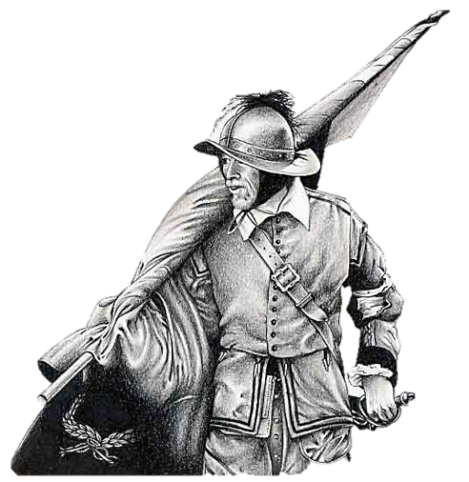
History
Format of the exam:
Knowledge questions
Source inference questions
Essay questions

Topics that need to be revised:
Elizabeth I
James I
Charles I (including The English Civil War).

Hints and tips for preparation:
Work on 3 mark inference questions. Many of the answers will follow this structure;
From the source it can be seen…
This is clear because…
This shows that….
Practice APE/PEE for your essay questions.
Essay questions should have an introduction, 2 APE paragraphs and a conclusion.
Remember to refer to or quote from all sources provided, that’s why they are there.
Use BUG and remain focused on what the question asks you to do.
Don’t leave any questions blank, have a go!

Stretch and challenge for top grades:
Use hierarchy in your essay questions; e.g. the most important reason etc.
Many of the question types will be found in GCSE examination papers and will be marked with those criteria.
Remember to go DEEP; Dates, Examples, Events and People.

Useful websites & where to find help:
Paignton Online, BBC Bitesize and also history club on a Thursday lunchtime in W05.

Year 8 examinations

Week beginning 23rd April 2018

Ethics
Format of the exam:
A 45 minute exam. Three topics – Human Rights, Creation Stories, Animal Rights and Buddhism. All students must attempt to answer all questions. All students will be familiar with the types of questions – keywords, opinions, knowledge and factual and balanced opinions.
Topics that need to be revised:
The exam will be based on the following areas studied in class.
- Human Rights
- Creation Stories
- Animal Rights
- Buddhism
Hints and tips for preparation:
All revision materials are available on the Revision Hub. There are also links to Quizlet.com which is a very useful resource for learning key terms and spellings. Come to the Year 8 Ethics after school revision session on Mondays. Take home the mind-maps and revision cards that will be prepared in lessons.

Stretch and challenge for top grades:
To get top grades you need to be aware of exam format, have thoroughly revised the prescribed topics, and to make sure you write in enough detail giving examples and key terms wherever possible.

Useful websites & where to find help:
All revision materials are provided on Revision Hub. Of course students may use any additional books or websites linked to the prescribed topics to further enhance personal knowledge of these topics.

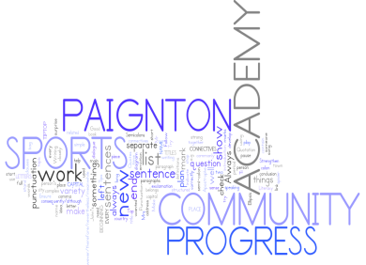
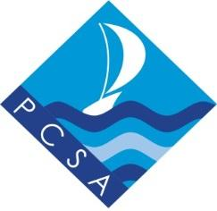
Year 8 examinations
Week beginning 23rd April 2018
French
Format of the exam:
1 hour
Reading Comprehension
Writing paper and translation from English to French.

Topics that need to be revised:
Saying where you live and would like to live.
Describing your home and using prepositions.
Talking about meals and what food to buy.
Talking about a forthcoming event.

Hints and tips for preparation:
Practice making a paragraph in preparation for the writing section and learn it this will speed things up for you and take the pressure off you in the exam.
Practice translation skills.
Learn vocabulary and the grammar structure so that you can recognise the meaning when it comes to understanding the gist of the reading comprehensions.

Stretch and challenge for top grades:
See writing section “Stretch and Challenge”- those aiming for Evaluating or Creating need to demonstrate confidence in handling one or two tenses. Make sure you are well prepared in advance of the exam, so that writing will be a breeze.

Useful websites & where to find help:
www.linguascope.com
Your teacher will tell you the username and password

Year 8 examinations

Week beginning 23rd April 2018

PE
Format of the exam: One 1 hour paper
The PE exam is made up of 38 questions, 100 marks in total.
Questions differ in how many marks are on offer.
Topics that need to be revised:
- Heart rate including how to calculate maximum heart rate.
- How oxygen is transported around the body.
- Major bones and functions of the skeleton.
- Major muscles and function of muscles.
- Skill-related and Physical-related fitness components
Hints and tips for preparation:
Pupils are to revisit the theory subjects they have been tested on at KS3
Make sure you have looked at every topic and not just your favourites. Highlight areas you are less confident in and ensure you spend time revising them
Revise a little and often. Avoid leaving all your revision to the night before your exam. Spend 30mins looking through revision material every other night
Make revision interactive – Create quizzes and ask family/friends to help test your knowledge.
Use the B.U.G. technique with exam style questions to help understanding.
Stretch and challenge for top grades:
Revise the major bones and muscles.
Know what the skill related components are and suggest a sporting example for each.
Know how to use connectives when structuring sentences to help describe / explain your answers.
Useful websites & where to find help:
Use the Y8 PE REVISION GUIDE which can be accessed via the PE section of the Revision Hub on the Academy website.
GCSE PE Bitesize website also has relevant information on Fitness Components and Human Anatomy.

