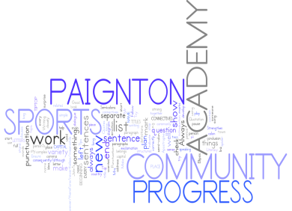
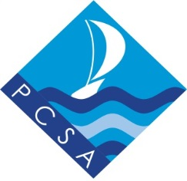
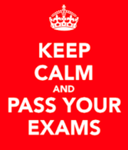

Year 10 PPEs (Pre-public examinations)

Week beginning 25th June 2018

GENERAL REVISION ADVICE

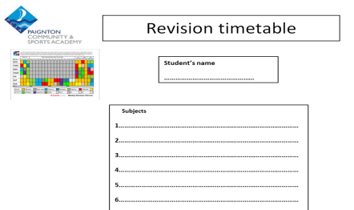
1. Make a revision timetable so that you can plan your revision.

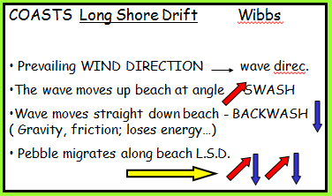
2. Try different ways of revising:
Mind maps
Doddle
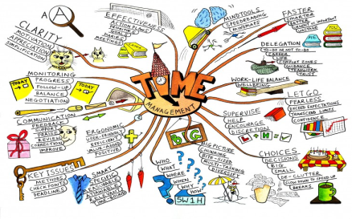
Flashcards
Highlight key words – reduce your notes
Revision apps/websites

3. BUG the question in the exams – Always read the questions!
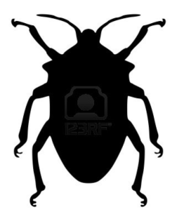
BUBBLE command words
UNDERLINE key points
GLANCE back

4. Find out from your teacher what a model answer looks like so that you can reach your target grade.
5. Spend at least two hours on revision each night.
2 hour on revision per night

6. Attend all revision sessions available to you.

7. Turn off all mobile devices whilst revising!
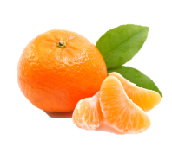
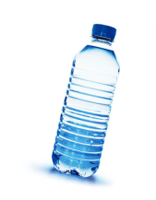
8. Get plenty of sleep before your exam and eat well.

9. Make sure that you have all the equipment you need for each
exam.

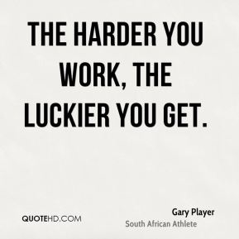
10.

Year 10 exam timetable w/b 25th June 2018
Tuesday 26th June
8.30 | 11.15 | 1.45
Option B  Computer Science – 1hr 30  Geography – 1hr 30  History – 55 mins  Ethics – 1hr 45  Art – 2hrs | English Paper 1 – 1hr 45
Wednesday 27th June
8.30 | 11.15 | 1.45
Separate Science Biology – 1hr 45  Combined Science Biology – 1hr 15 | Maths Paper 2 – 1hr 30
Thursday 28th June
8.30 | 11.15 | 1.45
Separate Science Chemistry – 1hr 45  Combined Science Chemistry – 1hr 15 | Option C  Computer Science – 1hr 30  Drama – 1hr 45  French – 1hr 45  Geography – 1hr 30  History 55 mins
Friday 29th June
8.30 | 11.15 | 1.45
Option A  French – 1hr 45  Geography – 1hr 30  History – 55 mins  Media Studies – 1hr 30 | English Paper 2 – 2hrs
Tuesday, 3rd July
8.30 | 11.15 | 1.45
Maths Paper 1 – 1hr 30 | Separate Science Physics – 1hr 45  Combined Science Physics – 1hr 15
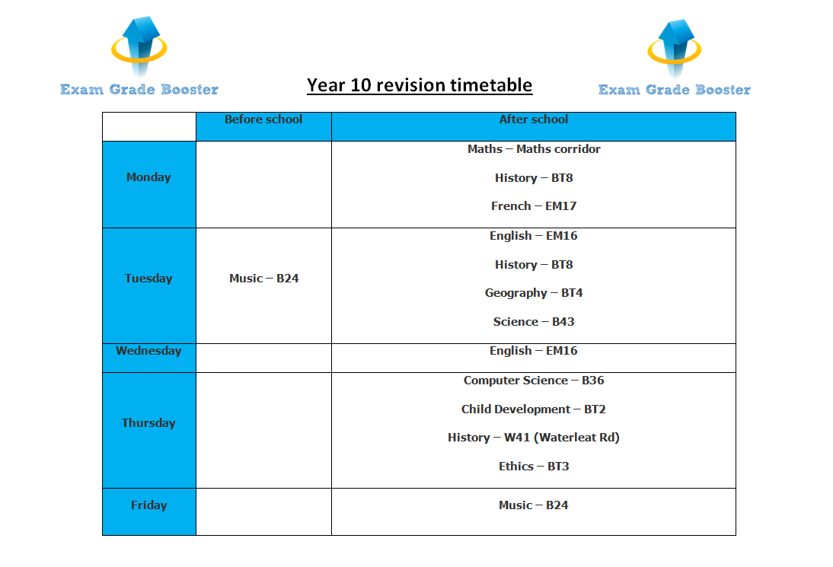

Year 10 Examinations

Week beginning 25th June

ENGLISH LANGUAGE – Paper 1
Useful websites & where to find help:
BBC Bitesize
Doddle
Grade Booster Sessions
PCSA Revision Hub
Google Classroom

Format of the exam:
Paper 1
19th Century Fiction & Imaginative Writing
1 Hour 45 Minutes – 1 Reading passage
Section A – 24 Marks One hour
Read Text 1 – Answer questions 1 – 4
Assessment objectives tested: AO1, AO2, AO4
Section B – 40 Marks (including 16 marks for SPAG) (45 Minutes)
You will choose ONE question and write a response
Assessment objectives tested: AO5, A06
Topics that need to be revised:
19th Century Fiction
Imaginative writing – Short stories, descriptions
Hints and tips for preparation:
Read a variety of 19th Century Fiction – ask to borrow texts from the English department
Analyse language and structure from a range texts
Practise writing within a specified time
Complete practice exam paper/questions
Attend Grade Booster sessions
Ask your English teacher for extra tasks to complete.

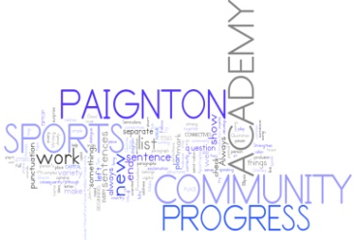
Year 10 Examinations

Week beginning 25th June

ENGLISH LANGUAGE – Paper 2
Useful websites & where to find help:
BBC Bitesize
Doddle
Grade Booster Sessions
PCSA Revision Hub
Google Classroom
Format of the exam:
Paper 2
20th & 21st Century Non-Fiction
2 Hours 2 Reading passages
Section A – 56 Marks One hour 15 minutes
Read Text 1 – Answer questions 1 – 3
Read Text 2 – Answer questions 4 – 6
Question 7 is about BOTH texts
Assessment objectives tested: AO1, AO2, AO3, AO4
Section B – 40 Marks (including 16 marks for SPAG) (45 Minutes)
You will choose ONE question and write a response
Assessment objectives tested: AO5, A06
Topics that need to be revised:
Non-Fiction – Language & Structure, Evaluation
Transactional Writing – Newspaper articles, magazine articles, speeches, letters

Hints and tips for preparation:
Read a variety of articles, travel writing, diary entries, autobiographical writing
Analyse language and structure from a range of articles/extracts
Practise writing within a specified time
Complete practice exam paper/questions
Attend Grade Booster sessions
Ask your English teacher for extra tasks to complete.

Year 10 Examinations

Week beginning 25th June

Edexcel GCSE Mathematics 9-1
Format of the exam:
Useful websites & where to find help:
www.kerboodle.com
Username : first letter of first name then surname e.g. : jsmith
Password: your personal school login
Institution Code: ifn4

Paper 1 – Non Calculator (80 marks) 90 mins
Paper 2 – Calculator (80 marks) 90 mins

Topics that need to be revised:
Units 1-9 from year 9 course:
Number, Expressions, Fractions-Decimals-%
Angles in Polygons, Handling Data,
Formulae and Functions, Working in 2D, Probability
Measures and Accuracy
Units 10 - 16 from year 10 course:
Equations and Inequalities, Circles and constructions, Ratio and proportion, Factors powers and roots, Graphs 1, Working in 3D
Hints and tips for preparation:
Look over your entire end of unit assessments to familiarise yourself with the types of question involved in each topic – secure topics/practise missed concepts. Use KERBOODLE to access the course book and practice the Review questions at the end of each chapter. We have built a google classroom which contains videos, extra practise exams, worksheets and worked examples on every topic you have covered. This will be a valuable resource in preparation for your exam.
Practise techniques and ask staff when unsure of methods, we are always here to help.

Year 10 Examinations

Week beginning 25th June

Trilogy Science and Separate Science

AQA Exam Board
Format of the exam:
- Examination – Biology Paper 1
Chemistry Paper 1
Physics Paper 1
Topics that need to be revised:
Trilogy and Separate Science
- Biology : Cell Biology; Organisation; Infection and Response; Bioenergetics
- Chemistry: Atomic Structure and the Periodic Table; Bonding, Structure and the Properties of Matter; Quantitative Chemistry; Chemical Changes; Energy Changes
- Physics: Energy; Electricity; Particle Model of Matter; Atomic Structure

Please note: Your exam and what should be revised depends on the course you are studying. This is either Trilogy Science or Separate Science (option subject).
Trilogy Science - Format of the exam:
- Biology – Paper 1 (foundation and higher)
  - 1 hour 15 minute exam that consists of 70 marks
- Questions in this exam will be both long and short response with questions relating to practical techniques. This will include calculations where appropriate. All questions will be on Biology.
- Topics that need to be revised:
  - Cell biology: microscopy, cell structure, stem cells, cell division, transport in cells
  - Organisation: digestive system, circulatory system, enzymes, plant organisation
  - Infection and Response: communicable and non-communicable diseases, pathogens, vaccines, drugs and their development.
  - Bioenergetics: photosynthesis, limiting factors, respiration (aerobic and anaerobic), metabolism
- Required Practical Activities: The following required practical activities should have been completed during lessons. Your exam may include questions from these activities.
  - Microscopy
  - Osmosis
  - Food Tests
  - Factors Affecting Enzyme Activity
  - The Effect of Light Intensity on Photosynthesis
- Chemistry – Paper 1 (foundation and higher)
  - 1 hour 15 minute exam that consists of 70 marks
- Questions in this exam will be both long and short response with questions relating to practical techniques. This will include calculations where appropriate. All questions will be on Chemistry.
- Topics that need to be revised:
  - Atomic Structure and the Periodic Table: elements and compounds, atoms and atomic structure.
  - Bonding, Structure and Properties of Matter: kinetic theory and types of bonding; ionic, covalent and metallic.
  - Quantitative Chemistry: relative formula mass, the mole and equations.
  - Chemical Changes: acids, based, salts and electrolysis.
  - Energy Changes: exothermic and endothermic reactions.
- Required Practical Activities: The following required practical activities should have been completed during lessons. Your exam may include questions from these activities.
  - Making Salts
  - Electrolysis
  - Endothermic and Exothermic Reactions

- Physics – Paper 1 (foundation and higher)
- 1 hour 15 minute exam that consists of 70 marks
- Questions in this exam will be both long and short response with questions relating to practical techniques. This will include calculations where appropriate. All questions will be on chemistry.
- Topics that need to be revised:
  - Energy: energy stores and systems, energy transfers, specific heat capacity, power, efficiency, energy resources and their uses, renewable and non-renewable energy resources.
  - Electricity: symbols, resistance, I-V characteristics, series and parallel, electricity in the home, power, the national grid.
  - Particle Model of Matter: density, motion in gases, internal energy and energy states, specific latent heat.
  - Atomic Structure: model of the atom, isotopes and nuclear radiation, nuclear equations, half-life, irradiation and contamination.

- Required Practical Activities: The following required practical activities should have been completed during lessons. Your exam may include questions from these activities.
  - Specific Heat Capacity
  - Circuits to Investigate Factors Affecting Resistance
  - Circuits to Investigate IV (current/voltage)
  - Density
Separate Science - Format of the exam:
- Biology/Chemistry/Physics Exam
  - 1 hour 45 minute exam that consists of 100 marks
- Questions in this exam will be both long and short response with questions relating to practical techniques. This will include calculations where appropriate. This exam will include questions on biology, chemistry and physics.
- Topics that need to be revised:
- Biology – Paper 1
  - 1 hour 45 minute exam that consists of 100 marks
- Questions in this exam will be both long and short response with questions relating to practical techniques. This will include calculations where appropriate. All questions will be on Biology.
- Topics that need to be revised:
  - Cell biology: microscopy, cell structure, stem cells, cell division, transport in cells.
  - Organisation: digestive system, circulatory system, enzymes, plant organisation.
  - Infection and Response: communicable diseases, pathogens, vaccines, drugs and their development, monoclonal antibodies, growing bacteria.
  - Bioenergetics: photosynthesis, limiting factors, respiration (aerobic and anaerobic), metabolism.
- Required Practical Activities: The following required practical activities should have been completed during lessons. Your exam may include questions from these activities.
  - Microscopy
  - Bacterial Growth
  - Osmosis
  - Food Tests
  - Factors Affecting Enzyme Activity
  - The Effect of Light Intensity on Photosynthesis
- Chemistry – Paper 1
  - 1 hour 45 minute exam that consists of 100 marks
- Questions in this exam will be both long and short response with questions relating to practical techniques. This will include calculations where appropriate. All questions will be on Chemistry.
- Topics that need to be revised:
  - Atomic Structure and the Periodic Table: elements and compounds, atoms and atomic structure, transition elements.
  - Bonding, Structure and Properties of Matter: kinetic theory and types of bonding, nanoparticles.
  - Quantitative Chemistry: relative formula mass, the mole and equations, percentage yield, titrations, volume of gases.
  - Chemical Changes: acids, based, salts and electrolysis.
  - Energy Changes: exothermic and endothermic reactions, chemical and fuel cells.
- Required Practical Activities: The following required practical activities should have been completed during lessons. Your exam may include questions from these activities.
  - Making Salts
  - Titration
  - Electrolysis
  - Endothermic Reactions
  - Exothermic Reactions
- Physics – Paper 1
  - 1 hour 45 minute exam that consists of 100 marks
- Questions in this exam will be both long and short response with questions relating to practical techniques. This will include calculations where appropriate. All questions will be on Physics.
- Topics that need to be revised:
  - Energy: energy stores and systems, energy equations, renewable and non-renewable resources.
  - Electricity: series and parallel circuits, resistance and power.
  - Particle Model of Matter: density, specific latent heat and internal energy.
  - Atomic Structure: isotopes and nuclear radiation, nuclear equations and half-life.
- Required Practical Activities: The following required practical activities should have been completed during lessons. Your exam may include questions from these activities.
  - Specific Heat Capacity
  - Material as Thermal Insulators
  - Circuits to Investigate Factors Affecting Resistance
  - Circuits to Investigate IV (Current/Voltage)
  - Density

Hints and tips for preparation:
Revision guides are available to purchase from your teacher for £5.75 (Trilogy only). See teacher for Separate Science.
Make sure you are using a number of different revision techniques in order for you to prepare fully. Make sure you are using your revision guides and your class work books in order to see what topics have been covered and therefore what you could have a question on.
Stretch and challenge for top grades:
For those students sitting the higher tier paper make sure you look at the higher tier sections in your revision guide and make sure you use past papers to practice your examination technique. Revision is also available on doddle.

Useful websites & where to find help:
Your teacher – let them know if you need some extra help and book a time to go through key areas for development.
Past paper practice – obtain from the AQA website or your teacher
Doddle

Year 10 Examinations

Week beginning 25th June

GEOGRAPHY

AQA GCSE 9-1 GEOGRAPHY
Format of the exam:
The examination will last for 90 minutes.
There will be THREE full GCSE questions, one on the living environment (ecosystems), one on UK landscapes (coasts & rivers) and one on urban environments.
Useful websites & where to find help:
BBC Bitesize
www.senecalearning.com
Doddle
AQA revision guide (ISBN: 978 1 78294 610 6)
You must answer ALL the questions.

Topics that need to be revised:
- Living Environment
- Small scale ecosystems – food chains, food webs
- Global biomes – location and distribution
- Rainforests – vegetation, adaptation, climate, opportunities
and challenges
- Cold environments – climate, adaptations, uses and the
opportunities and challenges
- Case studies – Amazon and Svalbard

- UK Landscapes
- River’s long profile and cross sectional shapes
- Features: waterfalls, interlocking spurs, meanders, ox-bow lakes, levees - River Tees
- Flooding: causes, effects and management & hydrographs
- Coastal landforms (cave, arch, stack, headland, wave cut platform, spit) and processes (erosion types and longshore drift)
- Coastal management

- Urban Issues and challenges
- Population: global growth and distribution of HICs and LICs
- Megacities: rise in number and their distribution – Lagos
- Urban areas in HIC - London
- Migration: push and pull factors
- Sustainable development – London 2012 redevelopment
Hints and tips for preparation:
Read the questions carefully and use the B.U.G. technique.
Look at the number of marks per question.
Study the resources carefully and provide evidence from the resources in your answers.
Follow all instructions – if it says draw a labelled diagram or use evidence or data in your answer you must, as marks are allocated for this.
Learn your case studies and ensure your case study matches the question - HIC or LIC.

Stretch and challenge for top grades:
Ensure that you demonstrate good geographical understanding. e.g. if the question asks about sustainability refer to social, economic and environmental sustainability.
Ensure you use connectives in your answers. E.g. However, as a result of, consequently,...

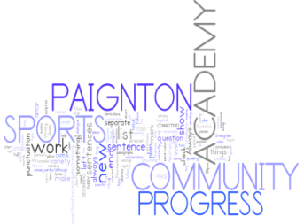
Year 10 Examinations

Week beginning 25th June

FRENCH

Exam board - WJEC
Format of the exam:
Reading exam- Foundation or Higher GCSE paper
Writing exam – English to French translation, 1 written question on holiday (90 words – Foundation, 150 words for Higher)
Listening exam- Foundation GCSE paper
Speaking exam – A picture card, a role play and a conversation on holidays
Topics that need to be revised:
Holidays
Grammar – present, imperfect, past and future tenses – Higher - conditional
Key holiday vocabulary
For Reading and Listening exams, revise general vocabulary
Hints and tips for preparation:
Ensure that you learn your written paragraphs on holidays and practice your speaking questions by reading them out loud.
Stretch and challenge for top grades:
Ensure that you learn all your complex structures, such as:
Après avoir joué/Après être allé(e) – After having played/After having been
Je me suis couché(e) à/Je me suis levé(e) à/Je me suis bronzé(e) – I went to bed at/I woke up at/I sunbathed
Si j’étais riche, je voyagerais …. – If I were rich, I would travel
S’il fera beau .. If it is going to be nice
Useful websites & where to find help:
http://revision.paigntononline.com/project/english-media-mfl/

Year 10 Examinations

Week beginning 25th June

HISTORY

Exam board – OCR B
Length of the exam:
The exam will last for 55 Minutes
Always begin by reading through the whole paper at the start of the exam.
Format of the paper: Elizabethan 1580-1603
You must answer question 1a & b and 2 and then choose to answer either question 3 or 4.
Interpretation question styles | Marks available
1. a) Source inference  Use Interpretation A to Identify and explain one way in which the illustrator…? | - marks
- b) Source plus knowledge  Use interpretation A to show understanding of Elizabethan life. | - marks
- Comparison between two different interpretations, use NOP  Explain the difference between interpretations B and C… | 12 marks
3. or 4. Essay Question – Choose only one  You will be presented with an historian’s interpretation about an event in the topic. You will need to present arguments supporting and disagreeing with that view. | 20 marks
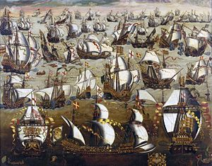

Hints and tips for preparation:
This exam is about different interpretations. An interpretation is an opinion or view.
Have a go at answering every question.
Practice APE for your essay. Practice Nature/Origin/Purpose for the 12 mark question.
Remember to refer to or quote from all sources provided, that’s why they are there.
Use BUG and remain focussed on what the question asks you to do.
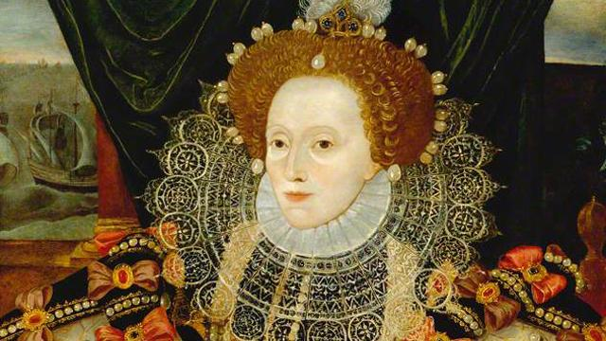

How can I make this my own ‘Golden Age’?
Visit www.paigntononline.com to access a wide range of revision resources
Come along to revision sessions in BT8 on Monday and Tuesday afternoons
Look out for the revision PowerPoints on the main school website
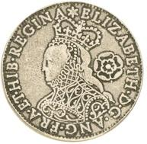
Visit BBC History and BBC bitesize for alternative sources of knowledge.

Stretch and challenge for top grades:
Use hierarchy in your essay questions; e.g. the most important reason etc.
Carefully choose a short Quote from ANY written Sources provided to enhance your answer.
Try to memorise a short quote about one of the above topics to enhance your writing.
Year 10 PPE Examinations

Week beginning 25th June

Ethics – AQA (A 8062)
Format of the exam:

The exam is based on the GCSE format. Students will sit the AQA Ethics GCSE in Year 11, but will be familiar with the style of questions and expected answer style. Students have completed many assessments using this format of 1,2,3,4 and 5 style questions. The exam is 1hr 45 minutes long, and comprises of four sets of questions. Students must select the relevant set of questions based on the topics they have studied this year and attempt all questions. There is a useful Ppt on the VLC with the revision materials to further remind and explain how to give 1-9 answers. There are also many revision Ppts linked to each topic. The paper is out of 96 marks, with an additional 5 marks awarded for SPaG – (Spellings and Grammar).
Each question is a certain type of question and requires a specific way of answering to gain full marks.
- Make sure you learn the topic keywords – both spelling and meaning – for Christian Practices, Islamic Practices, Peace & Conflict and Relationships & Families. These questions are worth 1 mark and just require you to select the correct answer from a choice of 4 key terms.

- These questions ask for two facts and are worth 2 marks. You do not need to write an explanation. A list of the two requested answers is enough to get full marks.

- These questions are worth 4 marks and ask you to explain something. To get full marks you need to identify a relevant idea and follow it with a reason or example. This should take you about 4 minutes to answer.

- These questions are worth 5 marks and ask you to explain something. It is similar to No.3 questions and to get full marks you need to identify a relevant idea and follow it with a reason or example. This should take you about 5 minutes to answer.

- These questions are worth 12 Marks – half the allocated mark for each section. They require you to explain reasons to support a statement, reasons to not support a statement and finally your own opinion supported by beliefs of others. This should take you about 12 minutes to answer.

Topics that need to be revised:
The exam will be based on al topics studied in Year 10.
- Relationships & Families
- Christian Practices
- Islam Practices
- Peace & Conflict
Students will also need to know the key terms for each of the four topics.

Hints and tips for preparation:
All revision materials are available on the VLC. There are also links to Quizlet.com which is a very useful resource for learning key terms and spellings.
Come to the Year 10 Ethics after school revision session.
Take home the mind-maps and revision cards that will be prepared in lessons.

Stretch and challenge for top grades:
To get top grades you need to be aware of exam format, have thoroughly revised the prescribed topics, and to make sure you write in enough detail giving examples and key terms wherever possible.

Useful websites & where to find help:
There are a wide variety of revision materials on Paignton Online. Students may also wish to buy a revision guide.
WARNING: We do not recommend using general sites such as BBC Bitesize for Ethics revision as they are not specific to the AQA exam content and you may become confused or learn topics that are not relevant or needed.
Ethics Revision Hub http://revision.paigntononline.com/
Key terms https://quizlet.com /
Recommended revision Guide New Grade 9-1 GCSE Religious Studies: AQA A Revision Guide with Online Edition. Product Code: RAR41 ISBN: 978 1 78294 641 0 £5.95
Please note when using the revision guide that the religions we are studying at PCSA are Christianity and Islam. The selected themes are Peace & Conflict, Families & Relationships and Family, Islamic & Christian Practices.

Christian Practices | Islam Practices
Worship | Festivals
Prayer | 10 Obligatory Acts
Baptism | Shahada
Eucharist | 5 Pillars
Pilgrimage | Prayer
Festivals | Zakat
Food Banks | Ramadan
Street Pastors | Hajj
Mission & Evangelism | Peace & Conflict
Christian Persecution | Causes & Consequences
Church response to poverty | Forgiveness, Justice & Reconciliation.
Relationships & Family | Violent protest & Terrorism
Sexuality | WMDs
Adultery & Pre-marital sex | Just War
Marriage | Holy War Islam
Contraception | Pacifism & Peace Making
Divorce & remarriage | Religion as a cause of war
Religion & C21st Families | Religious response to war
Religion & Gender Equality

Year 10 Examinations
Week beginning 25th June
Computer Science
Exam board - OCR
Format of the exam:
1.5 Hour Written Paper
Mixture of short answer and long answer questions based on theory from unit 1 – so all topics from 1.1 – 1.8.
Topics that need to be revised:
Unit | Topic
1.1 | System Architecture
1.2 | Memory
1.3 | Storage
1.4 | Wired and Wireless Networks
1.5 | Network Topologies, Protocols and Layers
1.6 | System Security
1.7 | System Software
1.8 | Ethical, Legal, Cultural and Environmental Issues
Hints and tips for preparation:
Ensure that you revise thoroughly using the work that you have done on Google Classroom. For each subject try and make sure that you have some examples that you can use as frequently marks can be awarded for adding an appropriate example.
Stretch and challenge for top grades:
There may be an algorithm question in the paper as algorithms can appear on both papers.
Useful websites & where to find help:
BBC Bitesize
Memrise.com
Google Classroom for lesson resources
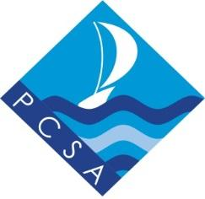
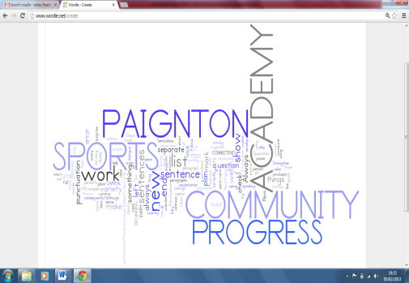
Year 10 Examinations
Week beginning 25th June 2018
GCSE DRAMA
Exam board – AQA
Exam will be in 3 sections:

Section A -Theatre terminology, role & responsibilities - 4 questions - 4 marks

Section B - Blood Brothers 4 essay questions on a given extract from the play
44 marks

Section C - Live Theatre Production 1 long essay question based on the production of ‘The Curious Incident of the Dog in the Night-Time’ 32 Marks

Revise:
For Section A - areas of the stage, types of staging and drama devices , job roles and responsibilities

Section B - Blood Brothers - notes in exercise books, videos of the production, resources on Google classroom and revision homework, costume, set, characters, plot

Section C notes from ‘The Curious Incident of the Dog in the Night-Time at the Theatre Royal, Plymouth. Videos, power points and resources on Google Classroom.

Hints and Tips:

GCSE Bitesize Drama for theatre roles, staging and terminology, and Blood Brothers
Google Classroom power points, videos and resources including past papers and exemplar answers.
Students folders for Blood Brothers and Section A questions

Stretch & challenge:
In section B & C, detailed references to vocal and physical skills used by the actors in specific scenes /moments and the impact on the audience is required with specific examples from the performance. Section C you are writing about HOW the ACTORS plays the characters, discuss your personal response to the production, choose 3 or 4 scenes to discuss in detail.

Useful websites: GCSE Bitesize
AQA GCSE Drama from 2016
Google Classroom

Year 10 Examinations
Week beginning 25th June
Media Studies
Exam board - AQA
Format of the exam:
1 hour 30 mins written paper
Mixture of short answer and long answer questions based on theory and practical work studied in class.
Topics that need to be revised:
- Online, Social & Participatory Media – Zoella, Kim Kardashian Hollywood, Lara Croft Go.
- Radio 1 Launch Day CSP
- Galaxy Chocolate CSP
- Film Distribution – I Daniel Blake & Dr. Strange
Hints and tips for preparation:
Ensure that you revise thoroughly using your notebooks and using the resources on Google Classroom.
Stretch and challenge for top grades:
Make sure that you plan the extended answers to include introductions and conclusions. Make sure you know media terminology and theories to put into your answers.
Useful websites & where to find help:
BBC Bitesize
Google Classroom for lesson resources

