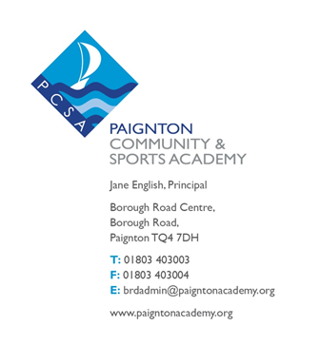
Date: 15th September 2015
Our Ref: MAS
Reply to: M Smith
At: Borough Road Centre

Dear Parent / Guardian
Re: Year 10 Key Stage 4 Success Evening - Thursday, 24th September at 6.30pm
We would like to invite you to this very important evening, the purpose of which is to support your son/daughter in their Key Stage 4 examination courses.
There have been significant changes to the GCSE’s, particularly in English and maths and it is important that everyone is familiar with the new grading system and what is now expected of the students in these vital subjects. Pupils will also be sitting some of their GCSE examinations at the end of Year 10, as well as completing a considerable amount of their Controlled Assessments, therefore it is essential that students understand the expectations required to be successful in their GCSE exams as early as possible.
The examination courses will place great demands on the students in the school, but past experience has shown that if students, teachers and parents work together there is a far greater chance that the youngsters will fulfil their potential. We know that informed, committed parents can have a huge influence in helping their child to succeed.
With this in mind, we would be extremely pleased to meet you at this special evening, so we can outline the requirements of the courses, suggest ways in which you can help and inform you of important dates in the near future. Furthermore, there will be tips and advice given to all the students present as to how they can manage their time, revise effectively and perform well in examinations. The school continues to work on improving communication with parents.
The format for the evening will be as follows:
6.30 – 6.45 – Presentation ‘The Challenge Ahead and How to Succeed’
6.45 – 8.30 – An opportunity to speak to the Academy’s subject teachers who will be able to give a detailed explanation of the specific requirements of each course
7.30 – 7.45 – Presentation ‘The Challenge Ahead and How to Succeed (this is a repeat of the talk at 6:30)

We hope you can attend the evening and are sure you will find it interesting and helpful.
Please fill in the slip below and return it to Mr Virgo/Mrs Rundle via their Form Tutor by Tuesday 22nd September.
Yours sincerely
M Smith
Deputy Principal
I can / cannot attend the Year 10 Key Stage 4 Success Evening on Thursday, 24th September.
(Please note I have arranged for Bookers to open their car park from 6:00-9:00 for parental use)

Pupil Name_____________________________ Form______________

Signed_________________________________

