Year 7 Extra Curricular Activities
!! EVERYONE WELCOME !!
Activity | When | Where
MONDAY
Free Play | Lunch | Field
Hub Club | Lunch | HUB
TUESDAY
Elite Basketball | Lunch | Gym
Hub Club | Lunch | HUB
Free Play | Lunch | Astro
Satellite Rowing | After school | Rowing Room
Girls’ Night | After school | Sports Hall
Girls’ Football | After school | Astro
Badminton | After school | Hub
Table Tennis | After school | Dining Hall
Softball | After school | Borough Road - Field
WEDNESDAY
Free Play | Lunch | Astro
Skating | Lunch | Sports Hall
Hub Club | Lunch | HUB
Girls’ Rugby | After school | Astro
Boys’ Rugby | After school | Field / Sports Hall
Dodgeball | After school | Gym
Netball | After school | HUB
THURSDAY
Free Play | Lunch | Astro
Hub Club | Lunch | HUB
Basketball | After school | Sports Hall
FRIDAY
Girls’ Basketball | Lunch | Gym
Free Play | Lunch | Astro
Hub Club | Lunch | HUB
Dance | Lunch | Drama Studio
Boys Football | After school | Astro
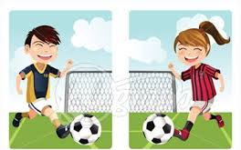
Lunchtime clubs run from 1:15 - 1.45pm
After School activities runs from 3-4pm

