Year 8 Extra Curricular Activities
!! EVERYONE WELCOME !!

Activity | When | Where
MONDAY
Free Play | Lunch | Astro
Hub Club | Lunch | HUB
TUESDAY
Hub Club | Lunch | HUB
Free Play | Lunch | Astro
Girls’ Football | After school | Astro
Badminton | After school | Hub
Dance | After school | Perf Arts Block
WEDNESDAY
Free Play | Lunch | Astro
Hub Club | Lunch | HUB
Girls’ Cricket | After school | HUB
Netball | After school | HUB
Dodgeball | After school | Gym
Table Tennis | After school | Dining Hall
THURSDAY
Free Play | Lunch | Astro
Hub Club | Lunch | HUB
Basketball | After school | Sports Hall
Boys Football | After school | Astro
Indoor Hockey | After school | BRC Sports Hall
FRIDAY
Dance | Lunch | Perf Arts Block
Free Play | Lunch | Astro
Hub Club | Lunch | HUB

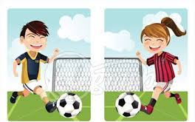
Lunchtime clubs run from 1:15 - 1.45pm
After School activities runs from 3-4pm

