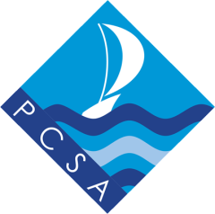
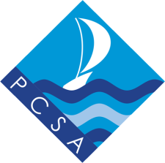
Paignton Community & Sports Academy
Gifted & Talented Sports Programmes

The following information outlines the gifted & talented programme offered by Paignton Community & Sports Academy (PCSA) to talented young sports people in the Paignton schools PE cluster

The aims of the programmes are:

- to recognise and celebrate achievements in sports performance
- to understand the pressures and commitments associated with high level sport and manage a package of support to aid young people with the additional challenges that they may face
- to assist talented young people in realising their potential through bespoke opportunities

Access to the programme is limited. Young people must complete and submit the attached application form in order to be considered for a place. Support completing the form is available through contacting any of the PE faculty at PCSA.

Gifted & Talented Sports Academy
Entry requirements: High performing athletes/players/coaches/officials aged 8 – 18, representing county level or above.
Package: All members of the Gifted & Talented Sports Academy will:
- have the opportunity to celebrate their achievements via the PCSA and Bay Academy Trust websites.
- be invited to attend an inspirational trip (subject to funding)
- be invited to attend a gifted & talented workshop
Applications can be submitted at any point during the year. Those accepted on to the programme may have more limited access to opportunities if they join the programme part way through the year.

For more information contact Mr Julyan, Cluster Development Manager – john.julyan@paigntonacademy.org

