PCSA
Revision
Help and
Useful Tips
for Year 11
Students

2017

A Guide to Revision

How to Revise – active or passive?

- Active revision means involving your eyes, ears and hands in different ways. Revising actively is the best way to make sense of the material you are trying to revise and it also helps you to remember it.

- Active methods of revision include:

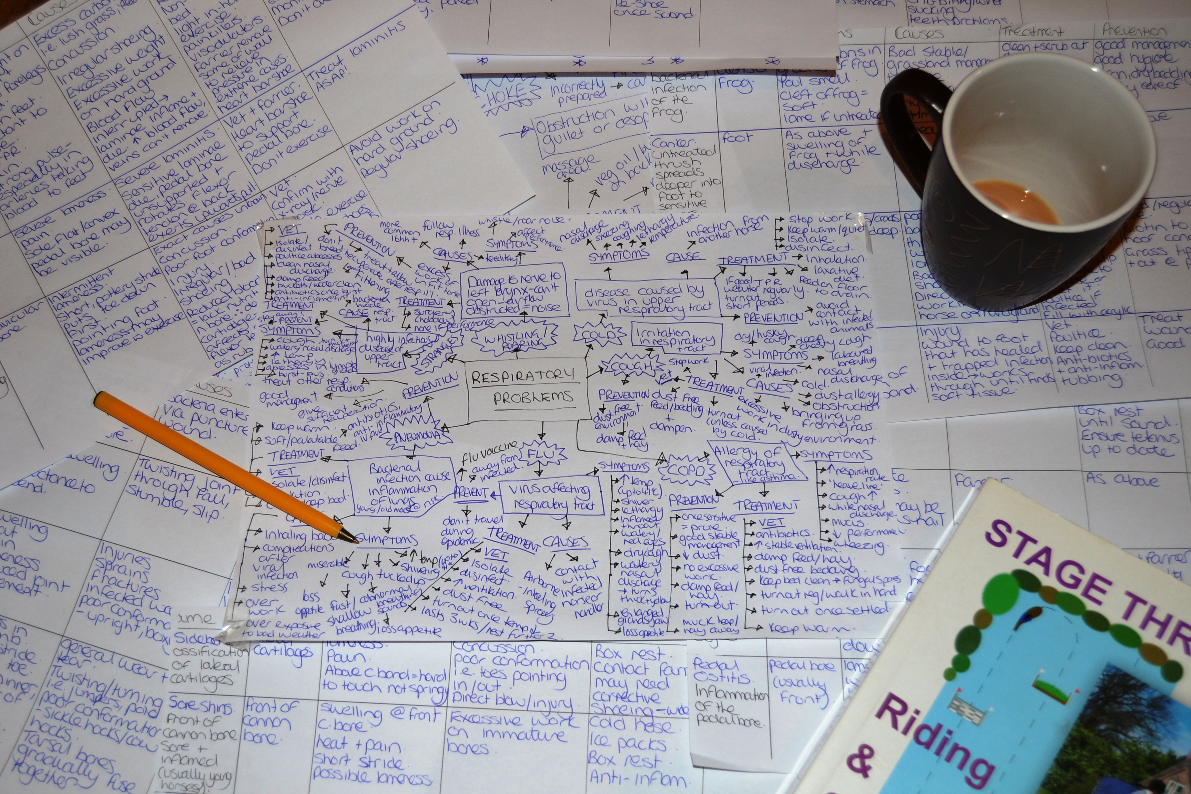
- writing revision notes;
- trying past exam papers;
- using revision websites.
- recording key points into your phone;
- discussing topics with a friend;
- testing yourself;
- reading notes aloud;
- getting others to test you;
- rewriting notes;
- doing examples:

You can use as many of these as you find useful.

- Passive reading through your notes and books is a bad method of revision. It doesn’t help you to understand or remember what you are revising. Please don’t just sit there reading page after page until you get bored! It won’t help!!

Revise with the Exam in Mind

- Find the exam board Specification or syllabus for each subject you have. Ask your teacher for this or they can be found on the Revision Hub. You can use this for as a basis for which topics to revise.

- For each paper make sure you know:

- how many papers you have to take;
- how long the exam will last and when it is;
- how many questions you have to answer;
- what choice of questions you have (if any);
- what type of questions are asked.

- Completing past papers is the best way to improve your exam technique.

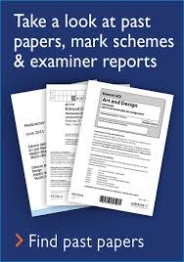
- When working through past papers you can write whole answers or brief answers using your revision cards or notes. Doing brief answers is a good way to practice essay questions.

- Some of your revision time should be devoted to practicing under exam conditions. This means putting away your books and avoiding any distractions such as phones! Stick to the time you have in the exam on each question. Get used to working at high speed for long periods of time because that is what you will be doing in most exams. The more timed questions you do, the better you will get at doing them.

- You will have different types of exam questions for different subjects. You should try to adjust your revision to the subject and try the questions you will get in that particular exam.

Writing your own Revision Notes

- Writing revision notes is a great way of being active in your revision. You are actually learning by writing!

- Revision notes should be created in the early stages of your revision. Don’t attempt to memorise all your lesson notes – condense them first.

- When you write your revision notes you are picking out the most important points and trying to reduce the amount of information to more bitesize chunks.

- Ways of making revision notes include:

- traditional notes on A4 file paper;
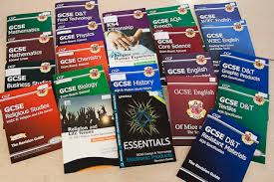
- revision cards;
- flashcards.

Choose the method which works best for you.

- Subject revision guides that you can buy in the shops or on-line are very helpful in your revision but they should not take the place of your own revision notes. It is very important that you write your own revision notes.

Writing Traditional Revision Notes

- Choose a topic or part of a topic that you want to revise. Look at ‘bite-size’ chunks of work and don’t try working with too large a topic at a time.

- Read through the notes you have on that topic. As you are reading ask yourself, “Do I understand this?”

- Pay attention to these points:

- make sure your notes are well SPACED OUT and don’t cram too much onto a page;
- use your own WORDS;
- use large writing and even better use CAPITAL LETTERS;
- make your revision notes INTERESTING by using pictures, colour, boxes, circles, underling, abbreviations, etc.

Making Revision Cards

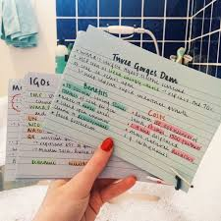
- Revision cards (or flashcards by another name) can be bought from any shop or get card from resources!

- They can be carried around in a pocket or bag and can be used wherever you are and whenever you’ve got a spare moment. They only contain a small amount of information so it is more manageable to learn.

- Take care with the following:

- always write the subject in the top right hand corner of the card;
- always put a title at the top of the card;
- develop your own method for numbering the cards;
- don’t be afraid to scrap a card and re-write if you are unhappy with it;
- cards covering the same subject or topic should always be kept together.

Creating Mind Maps

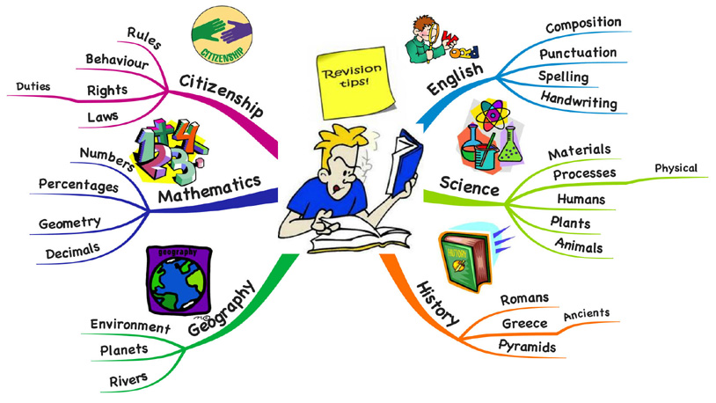
- Some students find mind maps more fun to do and more interesting to revise from.

- To write patterned notes or mind maps follow these steps:

- write the MAIN TOPIC in the middle of the paper and draw a ring around it;
- for each KEY POINT draw a branch out from the main topic;
- write a KEY WORD or PHRASE on each branch;
- build out further branches and add DETAILS:

- add diagrams, pictures and symbols where you can;
- highlight links and connections;
- be creative and personalise it.

Using your Revision Notes

- During a revision session:

- Choose a topic to revise and find your revision notes for this topic.
- Read the notes through, and as you do this try to recreate the whole topic in your mind.
- Place the notes face down and write out what you can remember.
- Compare the two and check for anything you may have missed out.
- If you have left out important details, test yourself again.
- If you need extra detail you can always refer back to your original notes.

How can I improve my memory?

- Here are five ideas which will help:

- You need to understand the information first. You will not be able to remember anything that you do not understand.
- Create memory hooks which help you to remember things. Hooks work best when they are crazy, unusual, and funny and yours! Use links, pictures, rhymes and stories to create hooks.
- Use your eyes, ears and hands when you’re trying to remember
information – be active.
- Recall the information regularly by testing yourself and getting friends to test you. Remember use it or lose it!
- Take bite-sized chunks of information and work with small amounts at a
time.

- One type of memory hook, called a mnemonic, uses the first letters from words you are trying to remember.

- An example of a memory hook is to take the first letter of a list of words and make a silly sentence of them. For example, the directions of the compass, North, East, South, West are recalled by using Naughty Elephants Squirt Water.

- Pictures can be good memory hooks.

- Making a song or rhyme can make a good hook to remember a list of things.

More Revision Ideas …

Getting Together

- Take full advantage of revision lessons and after school Grade Booster revision sessions. Your teachers are the best aid to revision you’ve got, listen to their advice and ask plenty of questions.

- Try organising a quiz with your friends.
- Ask family and friends to test you from your revision notes or try to explain a topic to them.

- Some students find it useful to get together with one or two friends who are doing the same exams for revision sessions. Decide the subject and topic you are going to look at and decide on how you will revise it.

Use Technology

- Check out the Academy’s Revision Hub which has a lot of useful information, put together by your teachers and other members of staff for each subject. www.revision.paigntononline.com. Paigntononline, the Academy’s VLE, also has load of information you my find helpful www.paigntononline.com. Both sites can be reached from the front page of our main website.

- There are some great revision websites.

- There are also some fantastic revision videos which cover all sorts of things including lessons on specific topics, working through past papers, worked examples, revision methods, revision planning and exam techniques.

- On some websites allow you to download audio revision onto your phone.

Testing, testing, testing …

- For important formulas, definitions, quotes and ideas test yourself regularly just before you go to sleep and when you wake up in the morning.

- When faced with having to learn a long list of items, such as French vocabulary try this:

- Learn the first two words on the list until you can write them out from memory.
- Add a third word and learn them all until you can write all three from memory.
- Add a fourth word and learn them all until you can write all four from memory and so on.

And more ideas still …..

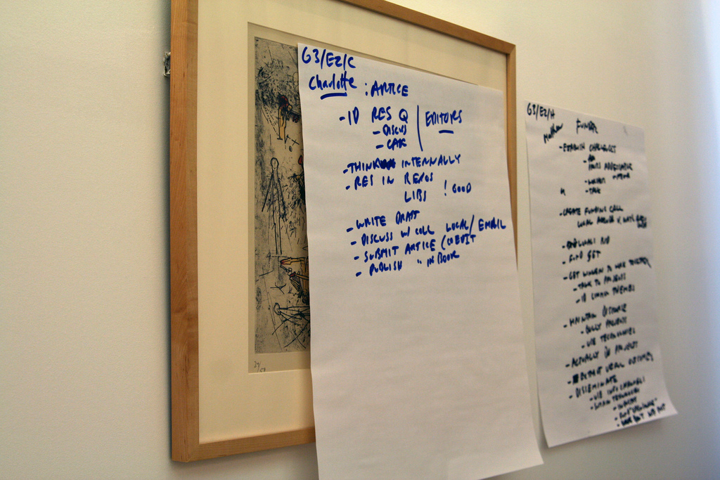
- Write key points on post-it notes and stick them to things such as a mirror wardrobe, door, etc.
- Write giant-size notes on large sheets of paper and stick them up in your bedroom.
- When working through past exams why not try starting with the last question and working backwards through the paper?!

Drawing up your Revision Timetable

About Revision Timetables

Getting Underway

- There are many good reasons for using revision timetables, these include:

- To avoid a last minute rush the night before the exam.
- To set up a routine.
- To share revision time between subjects – don’t always revise your best subjects!
- To keep up with your revision.
- To get the right balance between revision and free time.

What can go wrong?

- There are three main reasons why timetables don’t work out:

- They cover too many weeks ahead.
- They are in too much detail.
- They are over-ambitious and totally unrealistic!

- Timetables can work for everyone and a good timetable is one that strikes the right balance between flexibility and routine.

Drawing up a Timetable

- There are many ways to divide up the day. One simple way is to divide each day into three sessions: morning, afternoon and evening. For example:

- Morning Session: 9.00 am – 1.00 pm
- Afternoon Session: 1.00 pm – 5.00 pm
- Evening Session: 5.00 pm – 9.00 pm

- There are two suggested timetables on the following pages of this guide.

- Revision should only take place in short bursts with a break in between.

What steps do I follow in drawing up a Timetable?

Step 1 | Draw up a timetable lasting one week.
Step 2 | Work through your trial timetable.
Step 3 | Review your trial timetable.
Step 4 | Draw up a timetable for the next week and work through it.
Step 5 | Review the timetable.
Step 6 | Draw up your next timetable.
Now repeat steps 5 and 6 until you have sat your last exam.

What steps do I follow in drawing up a Timetable?

- Make a list of the subjects for which you are taking exams.

- The first timetable you draw up should only cover the first week from the date you start revision. This is trial period to enable you to find out how much revision you can realistically do.

- Add in all the extras such as lessons, time you will need to complete any unfinished controlled assessments or other study, clubs and most importantly time to relax.
- When drawing up a revision timetable consider the following ideas:

- leave time for relaxing;
- balance revision time between your subjects;
- space out the revision for each subject over the week;
- vary the subjects revised on each day.
Weekly Revision Timetable No 1
 | Monday | Tuesday | Wednesday | Thursday | Friday | Saturday | Sunday
Morning

Afternoon

Evening

Weekly Revision Timetable No 2
 | Monday | Tuesday | Wednesday | Thursday | Friday | Saturday | Sunday
8.00 am
9.00 am
10.00 am
11.00 am
12 noon
1.00 pm
2.00 pm
3.00 pm
4.00 pm
5.00 pm
6.00 pm
7.00 pm
8.00 pm
9.00 pm

Organising your Revision Sessions

Where do I start?

Making a Topic Checklist

- For each subject, make a list of the major topics that you have covered – this is called a topic checklist. If you have the exam board specification (this includes a list of topics that might come up in the exam) this can be helpful in checking what you need to cover.

- For each subject, look at the topics and decide what order you want to do them in. Pick a topic you like or find easy to start with as this boosts your confidence. Don’t leave your worst topic until last though!

- Pin up your topic checklists in your bedroom or keep them in an easily accessible place.

Organising your Time

Getting the Basics Right

- Spend 5 – 10 minutes at the beginning of each day making a plan for the day ahead. This may involve checking your revision timetable or if you’re not using one thinking about the subjects to revise.

- Set a definite time to start and finish each session and stick to it.
- IF YOUR PHONE IS NEARBY YOU WILL LOOK AT IT SO PUT IT IN A DIFFERENT ROOM!!

- If you are using a tablet or laptop to help with revision you will have to exercise some self-discipline.

- Keep revision sessions to a reasonable length. Between 1 – 3 hours is about right, but break it into half hour sessions.

- Try to work in a good light.

- Most people are at their best in the morning.

- If you are going to listen to music, play it at a low volume and choose something that doesn’t distract you. If you find yourself singing along then you are distracted!

Improving your Concentration

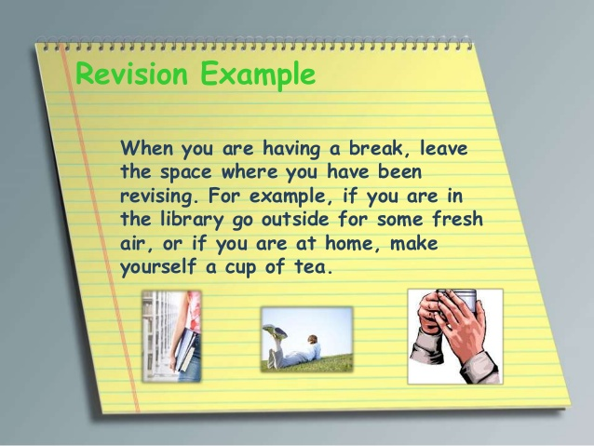
- If you find it difficult to concentrate for long periods of time, start with short sessions and gradually build up to longer sessions.

- Make sure you have regular breaks.

- Take advantage of the Academy revision classes. This is particularly helpful when it is difficult to get peace and quiet at home.

- Walking around whilst reading or testing yourself can help concentration.

More Ideas!

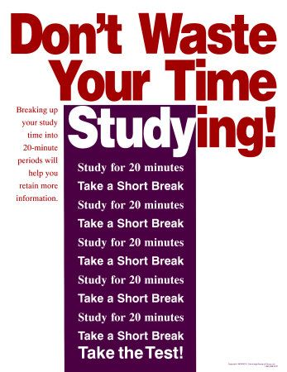
- Always end a revision session by summarising or testing yourself. You could divide up each hour in your revision session like this:

- 40 minutes revising
- 10 minutes testing
- 10 minutes resting

or, if the topic is particularly difficult and you are finding it difficult to concentrate:

- 20 minutes revising
- 50 minutes testing
- 50 minutes resting

- Keep a bottle of water nearby when you are revising.

- Clear your work area of everything except for relevant material and equipment and put away anything that might distract you – phone!!

- Give yourself something to look forward to or a reward after revision sessions – chocolate!

Going for Top Grades
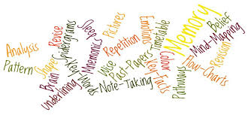

Make Revision a Priority

- In the period leading up to the exams make revision an important priority.

Start Early

- Start revising months, rather than weeks, before your first exam. Begin with a small amount of revision each week and gradually build up the number of hours. You will have too many exams on at once when the exam session starts; it will be too late to start revising then!

Put in the Hours

- There is no escaping the fact that in order to get the top grades you will have to put in long hours of work which sometimes is boring. This is particularly true if you want to get high grades in a lot of different subjects.

Revise all Topics

- To give yourself the best chance of achieving the top grades try not to have any ‘no go’ areas.

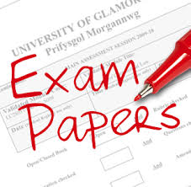
Tackle Past Papers

- Working through lots of past papers is important but there is much more to gain from doing this than simply getting used to exam questions. Use past papers as a way of finding out gaps in your understanding. Once you’ve identified these gaps revise these topics thoroughly. Use the mark schemes on the website to check your answers, and what should be in the answers!

Take every Opportunity to Revise

- Revision is a skill that needs practising, the more you do it the better you get. Make it a habit right from the beginning of your GCSE courses to take every opportunity to revise.

Use the Academy Revision Hub

- The new Academy Revision Hub has links to the exam boards, information on the specification for each subject, past papers and mark schemes, revision resources, exam dates, etc. You can find the link on the main Academy Website home page.

Use the Exam Board Websites

- Make visits to the exam board websites a regular part of your revision. Here you will find support materials including additional resources, past examination papers, model answers, exemplar materials and other subject resources.
Sitting your Exams

The Night Before

- Only attempt light revision using your revision notes.

- Get all the equipment you will need (pens, pencils, calculators, etc.) the night before.

- Try to get a normal night’s sleep if you can.

On the Day
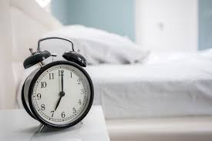
- Get up in plenty of time.

- When you leave home make sure you have everything you need for the exam.

- If you want to, do some last minute revision by flicking through your revision notes.

Compose Yourself

- The moment you first open your exam paper is always a bit of a shock. The exam never looks or reads quite the way you expect it to, so be prepared for this.

Read the Instructions Carefully

- Read the whole paper through carefully, noting all the instructions given about the number and choice of questions.

- If you have a choice of questions, select and mark those questions you feel confident that you are able to answer well.

- Decide on your question order, and then start by answering the questions you know you can answer well. This gives you more time to think about the difficult questions and boosts your confidence.

Watch your Time

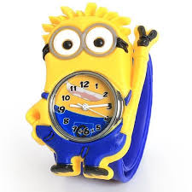
- Always take in a watch with you.

- You may wish to write down approximate finishing times for each question or section to help you see the progress you are making.

- Don’t fall into the trap of spending the most time trying to answer the questions about which you know very little.

Tackle the Questions

- Read every question at least twice, picking out key words. BUG the question, underline, and circle or highlight key words.

- Think about the question and analyse it before you get into your answer. Draw a mind map to help you order your thoughts. Get a sense of how long and detailed an answer is expected – look at how many marks it has been given.

- Remember to stick to what the question is asking. It is important that you answer the question you are being asked, not answering the question you would like it to be!

Coping with your Stress

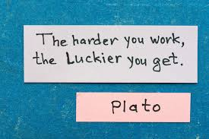
- Talk about it: think about the people you know who will listen to you and make sure you talk to them. Your listeners can be friends, family, teachers or others.
- Take time out to have some fun.
- Do some exercise.
- Think positively: a lot of exam success can be put down to positive thinking.
- Relax your Muscles.
- Eat well.

