Year 8 PE Extra Curricular Activities Autumn Term 2016
EVERYONE WELCOME!!

Activity | When | Where
Breakfast  Table Tennis Club | Monday and Wednesday Mornings | WRC Dining Hall
Astro Free Play | Every Lunchtime | WRC Astro
Hub Club | Every Lunchtime | WRC HUB
Roller-skating | Monday Lunchtime | WRC Sports Hall
Girls Night | Monday Afterschool | WRC Sports Hall
Satellite Table Tennis | Monday 4pm – 5pm | WRC Dining Hall - Invited
Girls Football | Tuesday After school | WRC Astro
Girls Rugby | Tuesday After school | WRC Astro
Dodgeball Club | Tuesday Afterschool | WRC Gym
Boys Rugby | Wednesday Afterschool | WRC Field
Netball | Wednesday Afterschool | WRC HUB
Table Tennis | Wednesday Afterschool | WRC Dining Hall
Boys Basketball | Thursday lunchtime | WRC Hub
Girls Basketball | Thursday Afterschool  Friday Lunchtime | WRC Sports Hall  WRC Gym
Badminton | Thursday Afterschool  Friday Lunch | WRC Hub
Boys Football | Friday Afterschool | WRC Astro
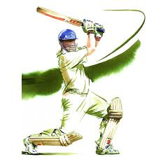

Breakfast clubs run from 8 - 8.30am

Lunchtime clubs run from 1.15-1.45pm

After school activities run from 3-4pm
Hub Club – Activities in the HUB – PLEASE WEAR TRAINERS!
Astroturf – free play - MUST WEAR SHINPADS AND TRAINERS OR ASTRO BOOTS (NO METAL STUDS/BLADES)

