Year 11 PE Extra Curricular Activities Autumn Term 2016
!! EVERYONE WELCOME !!
Activity | When | Where
Badminton Club | Tuesday Lunchtime  Thursday After School | BRC Sports Hall  WRC Hub
Fitness Suite / Gym Club | Every Lunchtime  Every day After school- Please note: Tuesday afterschool is girls night. | Fitness Suite
Wii Club | Monday Lunchtime  Tuesday Lunchtime  Friday Lunchtime | Wii Room: Main block second corridor
Girls Rugby Club | Tuesday After school | WRC Field
Trampolining Club | Wednesday After School | BRC Sports Hall
Table Tennis Club | Wednesday After School | Waterleat Road Dining Hall
Netball Club | Wednesday After school | WRC Hub
Yr 10 and 11 Basketball Club | Thursday After School | WRC Hub
Rugby Club | Thursday After school | BRC Field
Hockey Club | Thursday Afterschool | WRC Gym
Year 11 5 a side Football | Thursday Lunchtime | BRC Sports Hall
Year 11 Rugby | Thursday Afterschool | BRC Field
Sports Hall Free Play | Monday lunchtime | BRC Sports Hall

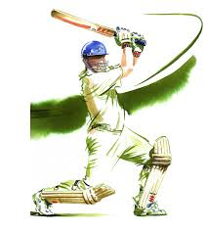
Lunchtime clubs run from 1:15 -1.45pm
After School activities run from 3-4pm

