Date: 14th May 2014

Our Ref: MJE/CR

Reply to: M J English
At: Waterleat Road Centre

To: All Academy Parents and Carers

Dear Parents and Carers

I am writing to inform you that Prospects Academies Trust is no longer sponsoring schools.

Attached to this letter is a statement from the Trust.

This means that we now have an exciting opportunity to look at the future of the Academy.

This change will not impact on the quality of education that we provide in the Academy. Please be assured that it is business as usual.

The uniform change will continue to take place in September.

If you would like to discuss this further do contact me and I will be pleased to speak with you.

Yours sincerely

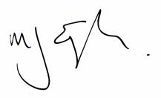

M J English
Principal

