Year 9 Extra Curricular Activities

Summer Term 2017
!! EVERYONE WELCOME !!
Activity | When | Where
MONDAY
Free Play | Lunchtime | Astro
Hub Club | Lunchtime | Hub
Girls Rugby | After school | WRC Field
Tennis | After school | Hub
TUESDAY
Free Play | Lunchtime | Astro
Hub Club | Lunchtime | Hub
Satellite Rowing Club | After school | Rowing Room
Athletics Club | After school | Astro
Rounder’s Fixtures | After school | Hub
Badminton | After school | Hub
WEDNESDAY
KS3 Dance Club | Lunchtime | Drama Studio
Free Play | Lunchtime | Astro
Hub Club | Lunchtime | Hub
Cricket | After School | Hub
Cricket | After school | Astro
Girls Rounder’s Club | After school | Astro
Capture the Flag | After School | BR Sports Hall
THURSDAY
Free Play | Lunchtime | Astro
Volleyball | After school | BR Sports Hall
FRIDAY
Girls Basketball | Lunchtime | WRC Gym
Free Play | Lunchtime | Astro
Hub Club | Lunchtime | Hub
Boys Football | After School | Astro

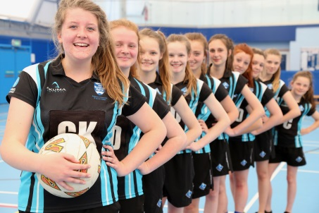
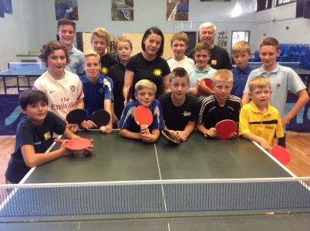
Breakfast clubs run from 8-8.30am
Lunchtime clubs run from 1-1.30pm
After school clubs run from 3-4pm

