Year 7 Extra Curricular Activities

Summer Term 2017
!! EVERYONE WELCOME !!
Activity | When | Where
MONDAY
 | Breakfast
Free Play | Lunchtime | Astro
Hub Club | Lunchtime | Hub
Girls Rugby | After school | WRC Field
Tennis | After school | Hub
TUESDAY
 | Breakfast
Free Play | Lunchtime | Astro
Hub Club | Lunchtime | Hub
Satellite Rowing Club | After school | Rowing Room
Athletics Club | After school | Astro
Rounder’s Fixtures | After school | Hub
Badminton | After School | Hub
WEDNESDAY
 | Breakfast
Free Play | Lunchtime | Astro
Hub Club | Lunchtime | Hub
KS3 Dance Club | Lunchtime | Drama Studio
Cricket | After school | Hub
Girls Rounder’s | After school | Astro
Cricket | After school | Hub
Capture the Flag | After school | BR Field
THURSDAY
Free Play | Lunchtime | Astro
Goal Ball | After school | Sports Hall
Volleyball | After School | BR Sports Hall
FRIDAY
 | Breakfast
Girls Basketball | Lunchtime | Gym
Free Play | Lunchtime | Astro
Hub Club | Lunchtime | Hub
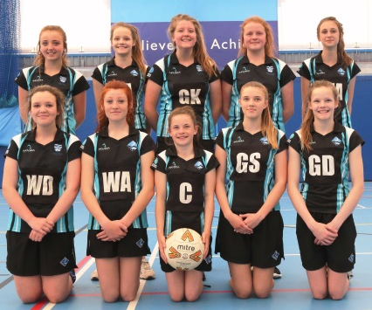

Breakfast clubs run from 8-8.30am
Lunchtime clubs run from 1-1.30pm
After school clubs run from 3-4pm

