Year 10 Extra Curricular Activities

Summer Term 2017
!! EVERYONE WELCOME !!
Activity | When | Where
MONDAY
Fitness Suite | Lunchtime | BR
Tennis | After school | Hub
Fitness Suite | After school | BR
TUESDAY
Boys Football | After School | BR Field
Athletics Club | After school | Astro
Badminton | After school | Hub
Ten Tours Training | After school | B10
BTEC OEd (level 3) Catch up | After School | B11
Fitness Suite | After School | BR
Girls Night – Invite Only | After School | Fitness Suite BR
WEDNESDAY
KS4 Breakfast Gym Club | Breakfast | BR Fitness Suite 7.35 -8.15am
Free Play | Lunchtime | Astro
Fitness Suite | Lunchtime | BR Fitness Suite
Cricket | After school | Astro
Cricket | After school | Hub
Capture the Flag | After school | BR Sports Hall
Fitness Suite | After school | BR Fitness Suite
KS4 Dance Support Rehearsal | After School | Dance Studio BR
KS4 BTEC Sports Catch Up | After School | PE1
THURSDAY
KS4 Breakfast Gym Club | Breakfast | BR Fitness Suite 7.35 – 8.15
Fitness Suite | Lunchtime | Fitness Suite
Free Play | After school | Astro
Basketball | After School | BR Sports Hall
Volleyball | After School | BR Sports Hall
Fitness Suite | After School | Fitness Suite
FRIDAY
Fitness Suite | Breakfast | Fitness Suite 8.00-8.30am
Free Play | Lunchtime | Astro
Hub Club | Lunchtime | Hub
Fitness Suite | Lunchtime | Fitness Suite
Fitness Suite | After School | Fitness Suite
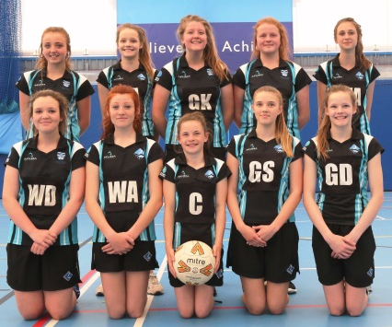
Breakfast clubs run from 8-8.30am
Lunchtime clubs run from 1-1.30pm
After school clubs run from 3-4pm

